Unit 2

Error Control: Error Detection & Correction: Linear block codes, Cyclic codes, Checksum.
Medium access: Framing, Stop and wait protocol, Stop and wait ARQ, Random access, Channelization
10.1 INTRODUCTION
Let us first discuss some issues related, directly or indirectly, to error detection and
Correction
.
Types of Errors

Whenever bits flow from one point to another, they are subject to unpredictable changes because of interference. This interference can change the shape of the signal. In a single-bit error, a 0 is changed to a 1 or a 1 to a O. In a burst error, multiple bits are changed.

For example, a 11100 s burst of impulse noise on a transmission with a data rate of 1200 bps might change all or some of the12 bits of information.

Single-Bit Error
The term single-bit error means that only 1 bit of a given data unit (such as a byte, character, or packet) is changed from 1 to 0 or from 0 to 1.

Figure 10.1 shows the effect of a single-bit error on a data unit.
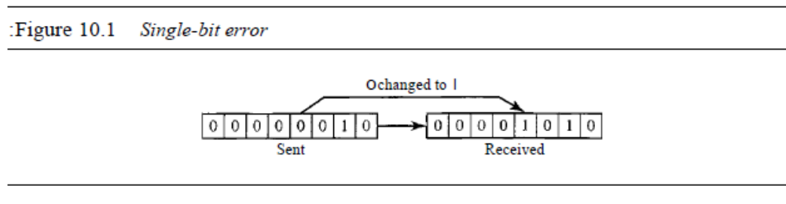
Single-bit errors are the least likely type of error in serial data transmission.

Burst Error

The term burst error means that 2 or more bits in the data unit have changed from 1 to 0 or from 0 to 1.A burst error means that 2 or more bits in the data unit have changed.

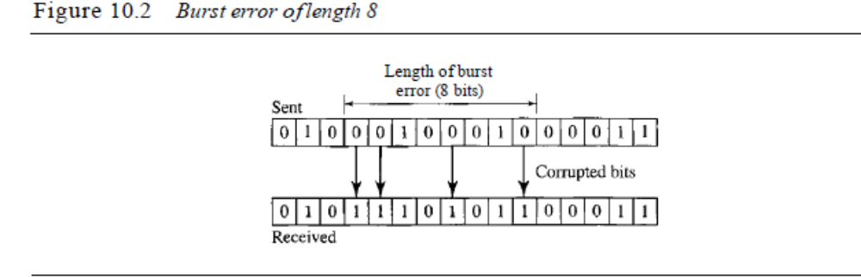
Figure 10.2 shows the effect of a burst error on a data unit. In this case,0100010001000011 was sent, but 0101110101100011 was received.
**Note that a burst error does not necessarily mean that the errors occur in consecutive bits.

Redundancy
The central concept in detecting or correcting errors is redundancy. To be able to detect or correct errors, we need to send some extra bits with our data. These redundant bits are added by the sender and removed by the receiver. Their presence allows the receiver to detect or correct corrupted bits. To detect or correct errors, we need to send extra (redundant) bits with data. Detection versus Correction
The correction of errors is more difficult than the detection.

In error detection, only to see if any error has occurred weather yes or no and not interested in the number of errors. A single-bit error is the same for us as a burst error.
In error correction, know the exact number of bits that are corrupted and their location in the message. The number of the errors and the size of the message are important factors. If we need to correct one single error in an 8-bit data unit, we need to consider eight possible error locations; if we need to correct two errors in a data unit of the same size, we need to consider 28 possibilities.(the receiver's difficulty in finding 10 errors in a data unit of 1000 bits.)

Forward Error Correction versus Retransmission

There are two main methods of error correction.
Forward error correction is the process in which the receiver tries to guess the message by using redundant bits. (only if the number of errors is small).

Correction by retransmission
Is a technique in which the receiver detects the occurrence of an error and asks the sender to resend the message. Resending is repeated until a message arrives that the receiver believes is error-free (usually, not all errors can be detected).

Coding
Redundancy is achieved through various coding schemes. The sender adds redundant bits through a process that creates a relationship between the redundant bits and the actual data bits. The receiver checks the relationships between the two sets of bits to detect or correct the errors. The ratio of redundant bits to the data bits and the robustness of the process are important factors in any coding scheme. Figure 10.3 shows the
general idea of coding. We can divide coding schemes into two broad categories: block coding and convolution coding.
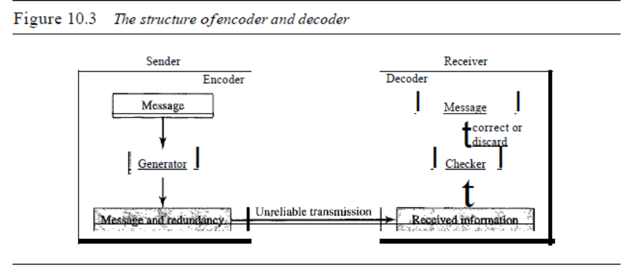
10.3 LINEAR BLOCK CODES
All block codes used belongs to subset called linear block codes. The use of nonlinear block codes for error detection and correction is not as widespread because their structure makes theoretical analysis and implementation difficult.

The formal definition of linear block codes requires the knowledge of abstract algebra A linear block code is a code in which the exclusive OR (addition modulo-2) of two valid code words creates another valid codeword.

In a linear block code, the exclusive OR (XOR) of any two valid code words creates another valid codeword.
Example 10.10
Let us see if the two codes we defined in Table 10.1 and Table 10.2 belong to the class of linear
block codes.
1. The scheme in Table 10.1 is a linear block code because the result of XORing any codeword
with any other codeword is a valid codeword. For example, the XORing of the second and
third code words creates the fourth one.
2. The scheme in Table 10.2 is also a linear block code. We can create all four code words by
XORing two other code words.

Minimum Distance for Linear Block Codes

It is simple to find the minimum Hamming distance for a linear block code. The minimum Hamming distance is the number of Is in the nonzero valid codeword with the smallest number of Is.

Example 10.11
In our first code (Table 10.1), the numbers of Is in the nonzero codewords are 2, 2, and 2. So the
minimum Hamming distance is dmin =2. In our second code (Table 10.2), the numbers of Is in
the nonzero codewords are 3, 3, and 4. So in this code we have dmin =3.
Some Linear Block Codes
Let us now show some linear block codes. These codes are trivial because we can easily
find the encoding and decoding algorithms and check their performances.
Simple Parity-Check Code
Perhaps the most familiar error-detecting code is the simple parity-check code. In this
code, a k-bit dataword is changed to an n-bit codeword where n = k + 1. The extra bit,
called the parity bit, is selected to make the total number of Is in the codeword even.
Although some implementations specify an odd number of Is, we discuss the even
case. The minimum Hamming distance for this category is dmin =2, which means that
the code is a single-bit error-detecting code; it cannot correct any error.
A simple parity-check code is a single-bit error-detecting
code in which n =k + 1 with dmin =2.
Our first code (Table 10.1) is a parity-check code with k -= 2 and n =3. The code in
Table 10.3 is also a parity-check code with k =4 and n =5.
Figure 10.10 shows a possible structure of an encoder (at the sender) and a decoder
(at the receiver).
The encoder uses a generator that takes a copy of a 4-bit data word (ao, aI' a2' and
a3) and generates a parity bit roo The data word bits and the parity bit create the 5-bit
codeword. The parity bit that is added makes the

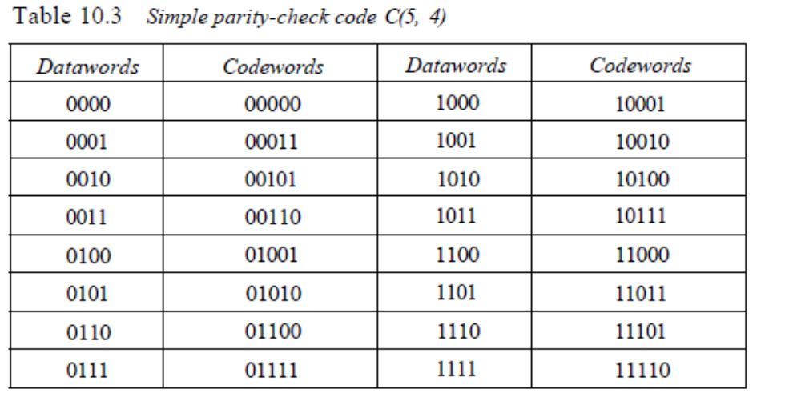
Figure 10.10 Encoder and decoder for simple parity-check code

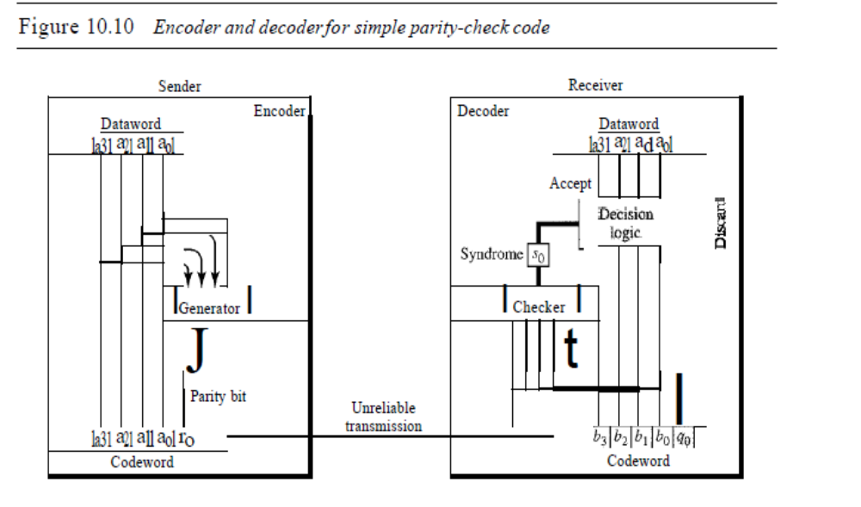

This is normally done by adding the 4 bits of the dataword (modulo-2); the result is the
parity bit. In other words,
If the number of 1s is even, the result is 0; if the number of 1s is odd, the result is 1.
In both cases, the total number of 1s in the codeword is even.
The sender sends the codeword which may be corrupted during transmission. The
receiver receives a 5-bit word. The checker at the receiver does the same thing as the generator
in the sender with one exception: The addition is done over all 5 bits. The result,
which is called the syndrome, is just 1 bit. The syndrome is 0 when the number of Is in the
received codeword is even; otherwise, it is 1.
280 CHAPTER 10 ERROR DETECTIONAND CORRECTION
The syndrome is passed to the decision logic analyzer. If the syndrome is 0, there is
no error in the received codeword; the data portion of the received codeword is accepted
as the dataword; if the syndrome is 1, the data portion of the received codeword is discarded.
The dataword is not created.
Example 10.12
Let us look at some transmission scenarios. Assume the sender sends the dataword 1011. The codeword
created from this dataword is 10111, which is sent to the receiver. We examine five cases:
1. No error occurs; the received codeword is 10111. The syndrome is O. The dataword 1011 is
created.
2. One single-bit error changes aI' The received codeword is 10011. The syndrome is 1. No
dataword is created.
3. One single-bit error changes roo The received codeword is 10110. The syndrome is 1. No dataword
is created. Note that although none of the dataword bits are corrupted, no dataword is
created because the code is not sophisticated enough to show the position of the corrupted bit.
4. An error changes ro and a second error changes a3' The received codeword is 00110. The syndrome
is O. The dataword 0011 is created at the receiver. Note that here the dataword is
wrongly created due to the syndrome value. The simple parity-check decoder cannot detect an
even number of errors. The errors cancel each other out and give the syndrome a value of O.
5. Three bits-a3, az, and aI-are changed by errors. The received codeword is 01011. The
syndrome is 1. The dataword is not created. This shows that the simple parity check, guaranteed
to detect one single error, can also find any odd number of errors.
A simple parity-check code can detect an odd number of errors.
A better approach is the two-dimensional parity check. In this method, the dataword
is organized in a table (rows and columns). In Figure 10.11, the data to be sent, five
7-bit bytes, are put in separate rows. For each row and each column, 1 parity-check bit is
calculated. The whole table is then sent to the receiver, which finds the syndrome for each
row and each column. As Figure 10.11 shows, the two-dimensional parity check can
detect up to three errors that occur anywhere in the table (arrows point to the locations of
the created nonzero syndromes). However, errors affecting 4 bits may not be detected.
Hamming Codes
Now let us discuss a category of error-correcting codes called Hamming codes. These
codes were originally designed with dmin = 3, which means that they can detect up to two
errors or correct one single error. Although there are some Hamming codes that can correct
more than one error, our discussion focuses on the single-bit error-correcting code.
First let us find the relationship between n and k in a Hamming code. We need to
choose an integer m >= 3. The values of nand k are then calculated from mas n = 2m - 1
and k ::: n - m. The number of check bits r =m.
All Hamming codes discussed in this book have dmin = 3.
The relationship between m and n in these codes is n = 2m - 1.
For example, ifm =3, then n ::: 7 and k::: 4. This is a Hamming code C(7, 4) with dmin =3.
Table 10.4 shows the datawords and codewords for this code.
SECTION 10.3 LINEAR BLOCK CODES 281
Figure 10.11 Two-dimensional parity-check code
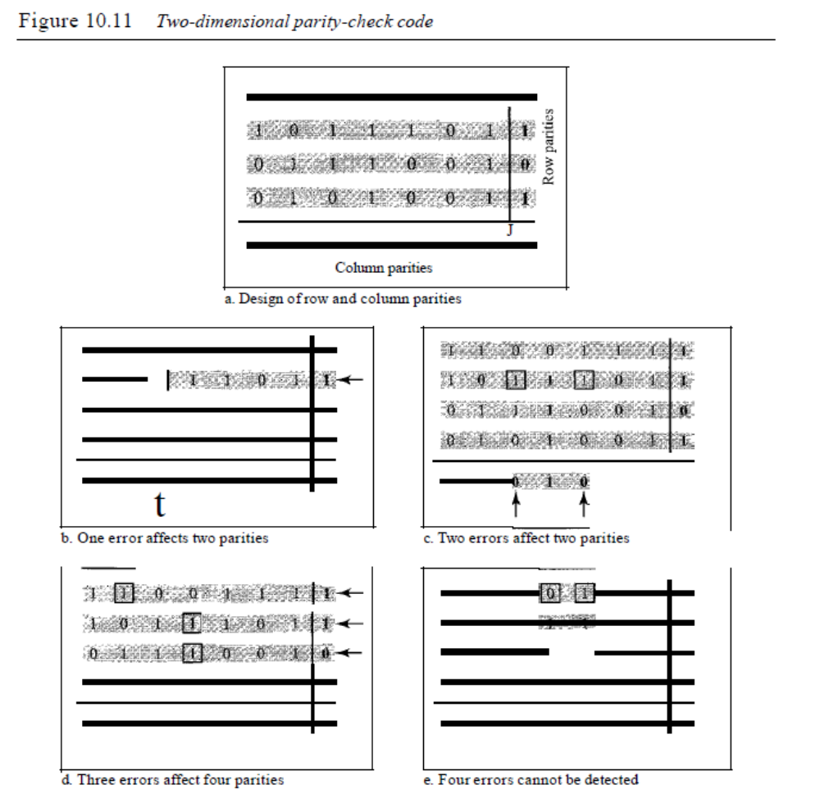
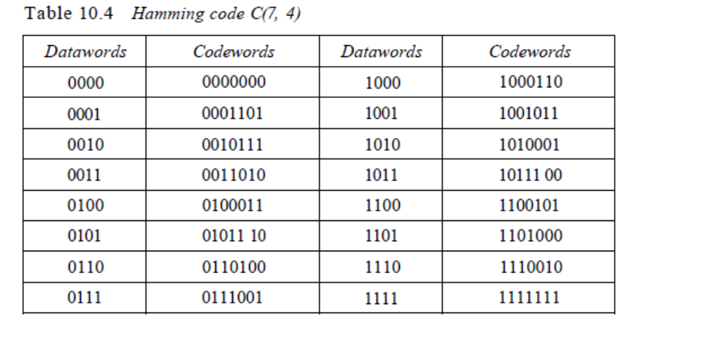Figure 10.12 shows the structure of the encoder and decoder for this example.
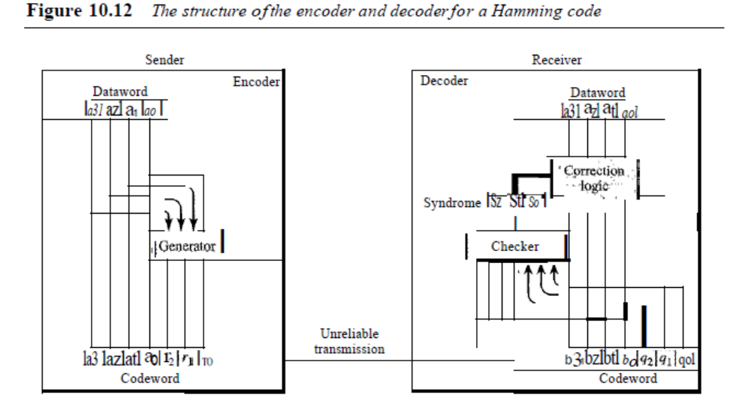
In other words, each of the parity-check bits handles 3 out of the 4 bits of the dataword.
The total number of 1s in each 4-bit combination (3 dataword bits and 1 parity
bit) must be even. We are not saying that these three equations are unique; any three
equations that involve 3 of the 4 bits in the dataword and create independent equations
(a combination of two cannot create the third) are valid.
The checker in the decoder creates a 3-bit syndrome (s2s1s0) in which each bit is
the parity check for 4 out of the 7 bits in the received codeword:
So == bz+ bi + bo+ qo
Sl =b3 + bz+ bI + ql
8Z == bl +bo+b3 +qz
modulo-Z
modulo-2
modulo-2
The equations used by the checker are the same as those used by the generator with
the parity-check bits added to the right-hand side of the equation. The 3-bit syndrome
creates eight different bit patterns (000 to 111) that can represent eight different conditions.
These conditions define a lack of error or an error in 1 of the 7 bits of the received
codeword, as shown in Table 10.5.
Table 10.5 Logical decision made by the correction logic analyzer a/the decoder
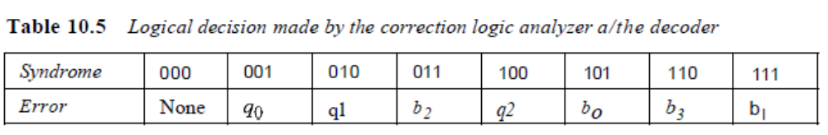
Note that the generator is not concerned with the four cases shaded in Table 10.5
because there is either no error or an error in the parity bit. In the other four cases, 1 of
the bits must be flipped (changed from 0 to 1 or 1 to 0) to find the correct dataword.
The syndrome values in Table 10.5 are based on the syndrome bit calculations. For
example, if qo is in error, So is the only bit affected; the syndrome, therefore, is 001. If
b2 is in error, So and s1 are the bits affected; the syndrome, therefore is OIl. Similarly, if
bI is in error, all 3 syndrome bits are affected and the syndrome is 111.
There are two points we need to emphasize here. First, if two errors occur during
transmission, the created dataword might not be the right one. Second, if we want to
use the above code for error detection, we need a different design.
Example 10.13
Let us trace the path of three datawords from the sender to the destination:
1. The dataword 0100 becomes the codeword 0100011. The codeword 01 00011 is received.
The syndrome is 000 (no error), the final dataword is 0100.
2. The dataword 0111 becomes the codeword 0111001. The codeword 0011001 is received.
The syndrome is 011. According to Table 10.5, b2 is in error. After flipping b2 (changing the
1 to 0), the final dataword is 0111.
3. The dataword 1101 becomes the codeword 1101000. The codeword 0001000 is received
(two errors). The syndrome is 101, which means that bois in error. After flipping ba, we get
0000, the wrong dataword. This shows that our code cannot correct two errors.
Example 10.14
We need a dataword of at least 7 bits. Calculate values of k and n that satisfy this requirement.
Solution
We need to make k =n - m greater than or equal to 7, or 21n
- 1 - m ~ 7.
1. If we set m =3, the result is n =23 - 1 and k =7 - 3, or 4, which is not acceptable.
2. If we set m =4, then n =24
- 1=15 and k =15 - 4 =11, which satisfies the condition. So the
code is C(l5, 11). There are methods to make the dataword a specific size, but the discussion
and implementation are beyond the scope of this book.
Performance
A Hamming code can only correct a single error or detect a double error. However,
there is a way to make it detect a burst error, as shown in Figure 10.13.
The key is to split a burst error between several codewords, one error for each
codeword. In data communications, we normally send a packet or a frame of data. To
make the Hamming code respond to a burst error of size N, we need to make N codewords out
of our frame. Then, instead of sending one codeword at a time, we arrange the codewords in a
table and send the bits in the table a column at a time. In Figure 10.13, the bits are sent colunm
by column (from the left). In each column, the bits are sent from the bottom to the top. In this
way, a frame is made out of the four codewords and sent to the receiver. Figure 10.13 shows
284 CHAPTER 10 ERROR DETECTIONAND CORRECTION
Figure 10.13 Burst error correction using Hamming code
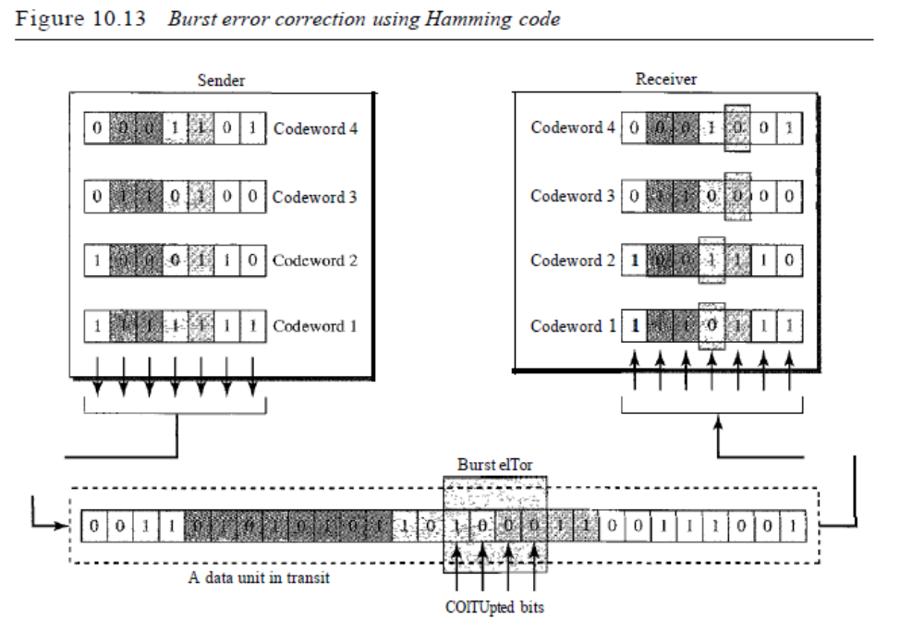
that when a burst error of size 4 corrupts the frame, only 1 bit from each codeword is corrupted.
The corrupted bit in each codeword can then easily be corrected at the receiver.
10.4 CYCLIC CODES
Cyclic codes are special linear block codes with one extra property. In a cyclic code, if
a codeword is cyclically shifted (rotated), the result is another codeword. For example,
if 1011000 is a codeword and we cyclically left-shift, then 0110001 is also a codeword.
In this case, if we call the bits in the first word ao to a6' and the bits in the second word
boto b6, we can shift the bits by using the following:
In the rightmost equation, the last bit of the first word is wrapped around and
becomes the first bit of the second word.
Cyclic Redundancy Check
We can create cyclic codes to correct errors. However, the theoretical background
required is beyond the scope of this book. In this section, we simply discuss a category
of cyclic codes called the cyclic redundancy check (CRC) that is used in networks
such as LANs and WANs.
SECTION 10.4 CYCUC CODES 285
Table 10.6 shows an example of a CRC code. We can see both the linear and cyclic
properties of this code.
Table 10.6 A CRC code with C(7, 4)
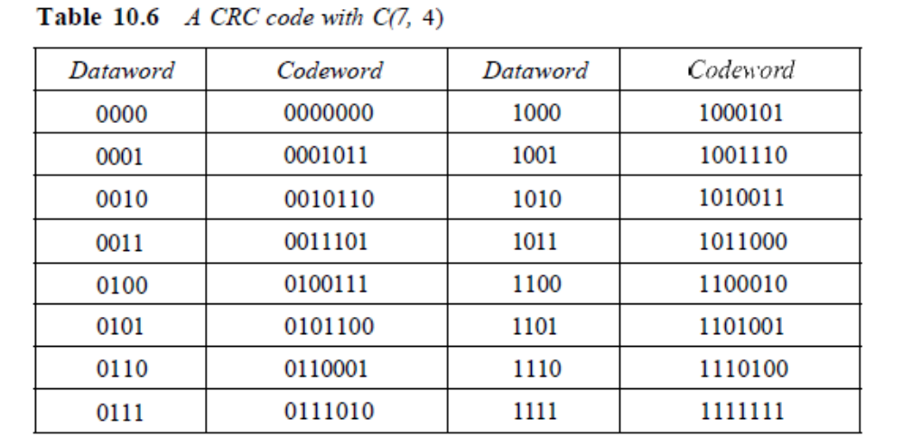

Figure 10.14 CRC encoder and decoder
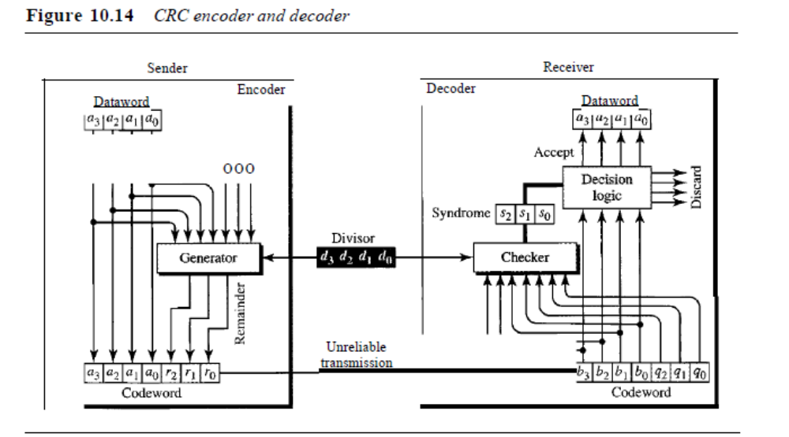In the encoder, the dataword has k bits (4 here); the codeword has n bits (7 here).
The size of the dataword is augmented by adding n - k (3 here) Os to the right-hand side
of the word. The n-bit result is fed into the generator. The generator uses a divisor of
size n - k + I (4 here), predefined and agreed upon. The generator divides the augmented
dataword by the divisor (modulo-2 division). The quotient ofthe division is discarded;
the remainder (r2rl ro) is appended to the dataword to create the codeword.
The decoder receives the possibly corrupted codeword. A copy of all n bits is fed to
the checker which is a replica of the generator. The remainder produced by the checker
286 CHAPTER 10 ERROR DETECTIONAND CORRECTiON
is a syndrome of n - k (3 here) bits, which is fed to the decision logic analyzer. The analyzer
has a simple function. If the syndrome bits are all as, the 4 leftmost bits of the
codeword are accepted as the dataword (interpreted as no error); otherwise, the 4 bits
are discarded (error).
Encoder
Let us take a closer look at the encoder. The encoder takes the dataword and augments
it with n - k number of as. It then divides the augmented dataword by the divisor, as
shown in Figure 10.15.
Figure 10.15 Division in CRC encoder
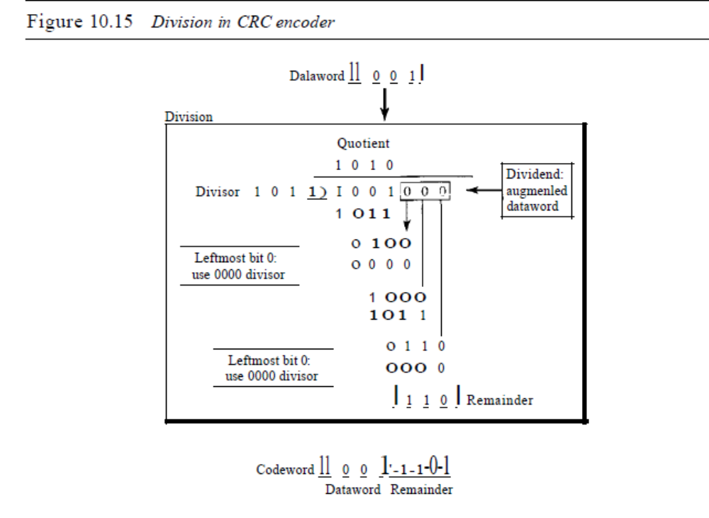The process of modulo-2 binary division is the same as the familiar division process
we use for decimal numbers. However, as mentioned at the beginning of the
chapter, in this case addition and subtraction are the same. We use the XOR operation
to do both.
As in decimal division, the process is done step by step. In each step, a copy of the
divisor is XORed with the 4 bits of the dividend. The result of the XOR operation
(remainder) is 3 bits (in this case), which is used for the next step after 1 extra bit is
pulled down to make it 4 bits long. There is one important point we need to remember
in this type of division. If the leftmost bit of the dividend (or the part used in each step)
is 0, the step cannot use the regular divisor; we need to use an all-Os divisor.
When there are no bits left to pull down, we have a result. The 3-bit remainder
forms the check bits (r2' rl' and ro). They are appended to the dataword to create the
codeword.
SECTION 10.4 CYCLIC CODES 287
Decoder
The codeword can change during transmission. The decoder does the same division
process as the encoder. The remainder of the division is the syndrome. If the syndrome
is all Os, there is no error; the dataword is separated from the received codeword and
accepted. Otherwise, everything is discarded. Figure 10.16 shows two cases: The lefthand
figure shows the value of syndrome when no error has occurred; the syndrome is
000. The right-hand part of the figure shows the case in which there is one single error.
The syndrome is not all Os (it is OIl).
Figure 10.16 Division in the CRC decoder for two cases
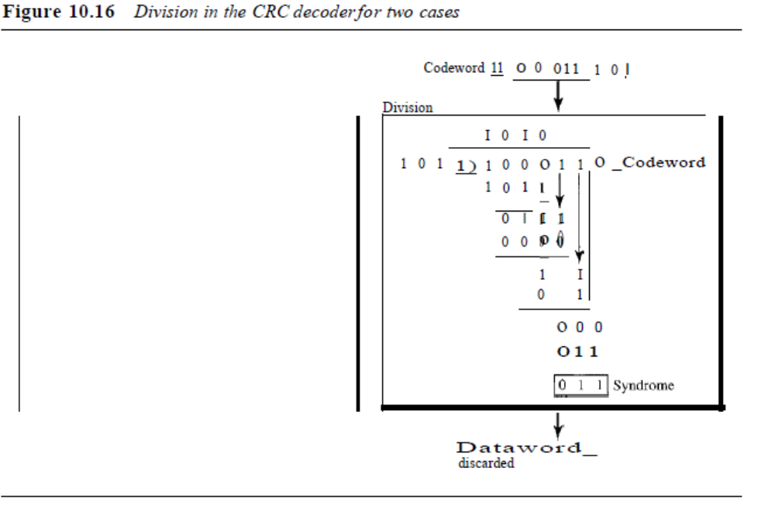Divisor
You may be wondering how the divisor] 011 is chosen. Later in the chapter we present
some criteria, but in general it involves abstract algebra.
Hardware Implementation
One of the advantages of a cyclic code is that the encoder and decoder can easily and
cheaply be implemented in hardware by using a handful of electronic devices. Also, a
hardware implementation increases the rate of check bit and syndrome bit calculation.
In this section, we try to show, step by step, the process. The section, however, is
optional and does not affect the understanding of the rest of the chapter.
Divisor
Let us first consider the divisor. We need to note the following points:
1. The divisor is repeatedly XORed with part of the dividend.
288 CHAPTER 10 ERROR DETECTIONAND CORRECTION
2. The divisor has n - k + 1 bits which either are predefined or are all Os. In other
words, the bits do not change from one dataword to another. In our previous example,
the divisor bits were either 1011 or 0000. The choice was based on the leftmost
bit of the part of the augmented data bits that are active in the XOR operation.
3. A close look shows that only n - k bits of the divisor is needed in the XOR operation.
The leftmost bit is not needed because the result of the operation is always 0, no
matter what the value of this bit. The reason is that the inputs to this XOR operation
are either both Os or both 1s. In our previous example, only 3 bits, not 4, is actually
used in the XOR operation.
Using these points, we can make a fixed (hardwired) divisor that can be used for a cyclic
code if we know the divisor pattern. Figure 10.17 shows such a design for our previous
example. We have also shown the XOR devices used for the operation.
Figure 10.17 Hardwired design ofthe divisor in CRC
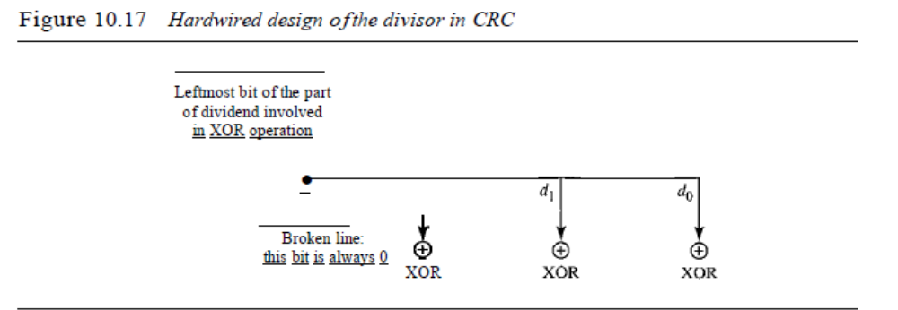Note that if the leftmost bit of the part of dividend to be used in this step is 1, the
divisor bits (d2d1do) are all; if the leftmost bit is 0, the divisor bits arc 000. The design
provides the right choice based on the leftmost bit.
Augmented Dataword
In our paper-and-pencil division process in Figure 10.15, we show the augmented dataword
as fixed in position with the divisor bits shifting to the right, 1 bit in each step.
The divisor bits are aligned with the appropriate part of the augmented dataword. Now
that our divisor is fixed, we need instead to shift the bits of the augmented dataword to the
left (opposite direction) to align the divisor bits with the appropriate part. There is no
need to store the augmented dataword bits.
Remainder
In our previous example, the remainder is 3 bits (n - k bits in general) in length. We can
use three registers (single-bit storage devices) to hold these bits. To find the final
remainder of the division, we need to modify our division process. The following is the
step-by-step process that can be used to simulate the division process in hardware (or
even in software).
1. We assume that the remainder is originally all Os (000 in our example).
SECTION 10.4 CYCLIC CODES 289
2. At each time click (arrival of 1 bit from an augmented dataword), we repeat the
following two actions:
a. We use the leftmost bit to make a decision about the divisor (011 or 000).
b. The other 2 bits of the remainder and the next bit from the augmented dataword
(total of 3 bits) are XORed with the 3-bit divisor to create the next remainder.
Figure 10.18 shows this simulator, but note that this is not the final design; there will be
more improvements.
Figure 10.18 Simulation ofdivision in CRC encoder
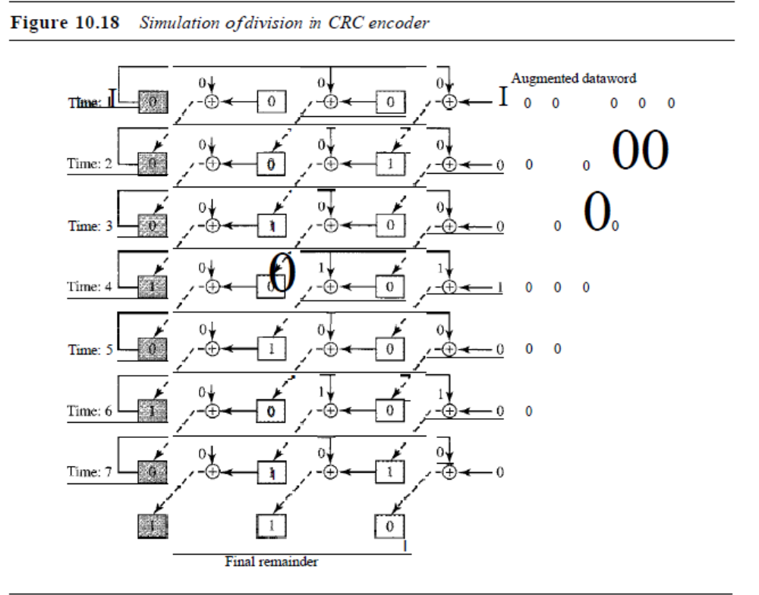At each clock tick, shown as different times, one of the bits from the augmented
dataword is used in the XOR process. If we look carefully at the design, we have seven
steps here, while in the paper-and-pencil method we had only four steps. The first three
steps have been added here to make each step equal and to make the design for each step
the same. Steps 1, 2, and 3 push the first 3 bits to the remainder registers; steps 4, 5, 6,
and 7 match the paper-and-pencil design. Note that the values in the remainder register
in steps 4 to 7 exactly match the values in the paper-and-pencil design. The final remainder
is also the same.
The above design is for demonstration purposes only. It needs simplification to be
practical. First, we do not need to keep the intermediate values of the remainder bits;
we need only the final bits. We therefore need only 3 registers instead of 24. After the
XOR operations, we do not need the bit values of the previous remainder. Also, we do
not need 21 XOR devices; two are enough because the output of an XOR operation in
which one of the bits is 0 is simply the value of the other bit. This other bit can be used
as the output. With these two modifications, the design becomes tremendously simpler
and less expensive, as shown in Figure 10.19.
Figure 10.19 The CRC encoder design using shift registers
- 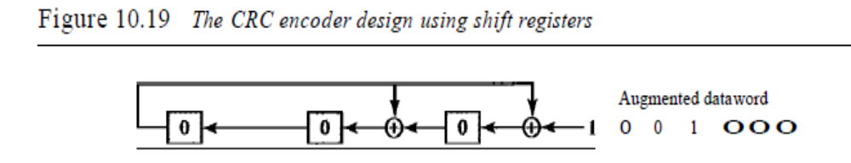We need, however, to make the registers shift registers. A I-bit shift register holds
a bit for a duration of one clock time. At a time click, the shift register accepts the bit at
its input port, stores the new bit, and displays it on the output port. The content and the
output remain the same until the next input arrives. When we connect several I-bit shift
registers together, it looks as if the contents of the register are shifting.
General Design
A general design for the encoder and decoder is shown in Figure 10.20.
Figure 10.20 General design ofencoder and decoder ofa CRC code
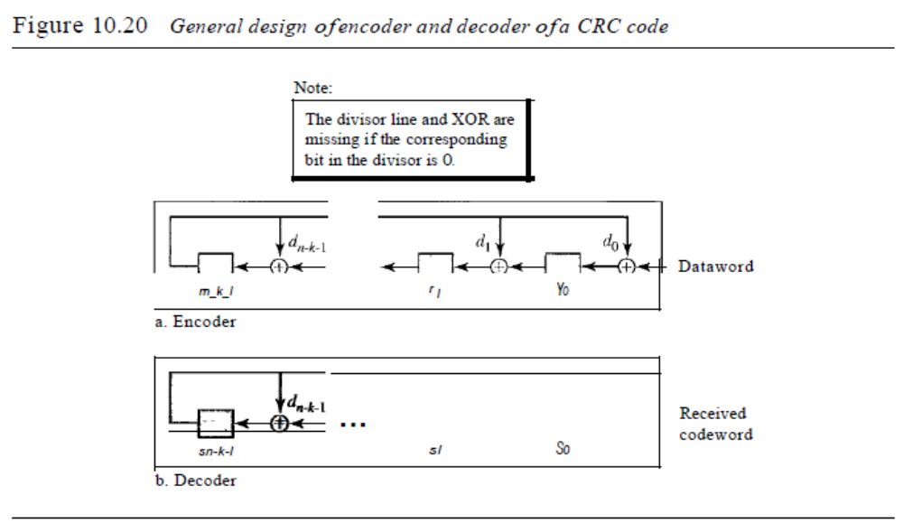
b. Decoder
Note that we have n - k I-bit shift registers in both the encoder and decoder. We
have up to n - k XOR devices, but the divisors normally have several Os in their pattern,
which reduces the number of devices. Also note that, instead of augmented datawords,
we show the dataword itself as the input because after the bits in the dataword are all
fed into the encoder, the extra bits, which all are Os, do not have any effect on the rightmost
XOR. Of course, the process needs to be continued for another n - k steps before
SECTION 10.4 CYCLIC CODES 291
the check bits are ready. This fact is one of the criticisms of this design. Better schemes
have been designed to eliminate this waiting time (the check bits are ready after k steps),
but we leave this as a research topic for the reader. In the decoder, however, the entire
codeword must be fed to the decoder before the syndrome is ready.
Polynomials
A better way to understand cyclic codes and how they can be analyzed is to represent
them as polynomials. Again, this section is optional.
A pattern of Os and 1s can be represented as a polynomial with coefficients of 0 and
1. The power of each term shows the position of the bit; the coefficient shows the value
of the bit. Figure 10.21 shows a binary pattern and its polynomial representation. In Figure
10.21a we show how to translate a binary pattern to a polynomial; in Figure 1O.21b
we show how the polynomial can be shortened by removing all terms with zero coefficients
and replacing xl by x and xO by 1.
Figure 10.21 A polynomial to represent a binary word
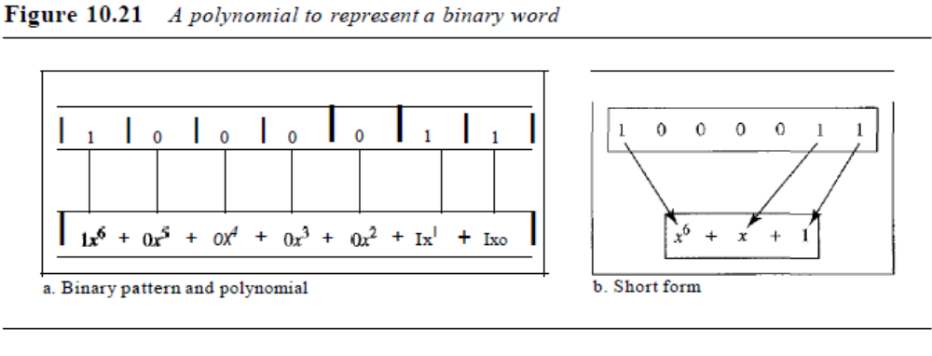a. Binary pattern and polynomial b. Short form
Figure 10.21 shows one immediate benefit; a 7-bit pattern can be replaced by three
terms. The benefit is even more conspicuous when we have a polynomial such as x23 +
X3 + 1. Here the bit pattern is 24 bits in length (three Is and twenty-one Os) while the
polynomial is just three terms.
Degree ofa Polynomial
The degree of a polynomial is the highest power in the polynomial. For example, the
degree of the polynomial x6 + x + 1 is 6. Note that the degree of a polynomial is 1 less
that the number of bits in the pattern. The bit pattern in this case has 7 bits.
Adding and Subtracting Polynomials
Adding and subtracting polynomials in mathematics are done by adding or subtracting
the coefficients of terms with the same power. In our case, the coefficients are only 0
and 1, and adding is in modulo-2. This has two consequences. First, addition and subtraction
are the same. Second, adding or subtracting is done by combining terms and
deleting pairs of identical terms. For example, adding x5 + x4 + x2 and x6 + x4 + x2 gives
just x6 + x5. The terms x4 and x2 are deleted. However, note that if we add, for example,
three polynomials and we get x2 three times, we delete a pair of them and keep the third.
Multiplying or Dividing Terms
In this arithmetic, multiplying a term by another term is very simple; we just add the
powers. For example, x3 x x4 is x7 , For dividing, we just subtract the power of the second
term from the power of the first. For example, x51x2 is x3.
Multiplying Two Polynomials
Multiplying a polynomial by another is done term by term. Each term of the first polynomial
must be multiplied by all terms of the second. The result, of course, is then simplified,
and pairs of equal terms are deleted. The following is an example:
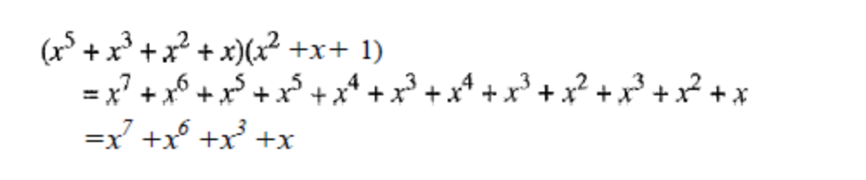
Dividing One Polynomial by Another
Division of polynomials is conceptually the same as the binary division we discussed
for an encoder. We divide the first term of the dividend by the first term of the divisor to
get the first term of the quotient. We multiply the term in the quotient by the divisor and
subtract the result from the dividend. We repeat the process until the dividend degree is
less than the divisor degree. We will show an example of division later in this chapter.
Shifting
A binary pattern is often shifted a number of bits to the right or left. Shifting to the left
means adding extra Os as rightmost bits; shifting to the right means deleting some rightmost
bits. Shifting to the left is accomplished by multiplying each term of the polynomial
by xn, where m is the number of shifted bits; shifting to the right is accomplished by
dividing each term of the polynomial by xn. The following shows shifting to the left and
to the right. Note that we do not have negative powers in the polynomial representation.
Shifting left 3 bits:
Shifting right 3 bits:
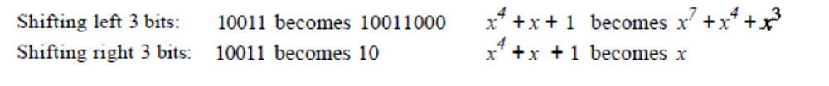When we augmented the dataword in the encoder of Figure 10.15, we actually
shifted the bits to the left. Also note that when we concatenate two bit patterns, we shift
the first polynomial to the left and then add the second polynomial.
Cyclic Code Encoder Using Polynomials
Now that we have discussed operations on polynomials, we show the creation of a codeword
from a dataword. Figure 10.22 is the polynomial version of Figure 10.15. We can
see that the process is shorter. The dataword 1001 is represented as x3 + 1. The divisor
1011 is represented as x3 + x + 1. To find the augmented dataword, we have left-shifted
the dataword 3 bits (multiplying by x\ The result is x6 + x3
. Division is straightforward.
We divide the first term of the dividend, x6, by the first term of the divisor, x3. The first
term of the quotient is then x6/x3, or x3. Then we multiply x3 by the divisor and subtract
(according to our previous definition of subtraction) the result from the dividend. The
SECTION 10.4 CYCLiC CODES 293
result is x4, with a degree greater than the divisor's degree; we continue to divide until
the degree of the remainder is less than the degree of the divisor.
Figure 10.22 CRC division using polynomials
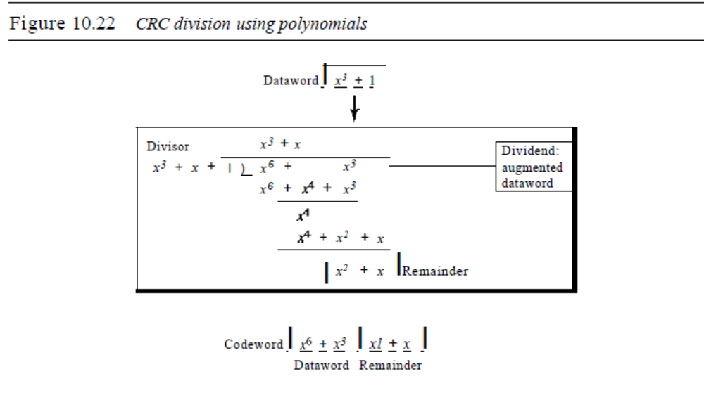It can be seen that the polynomial representation can easily simplify the operation
of division in this case, because the two steps involving all-Os divisors are not needed
here. (Of course, one could argue that the all-Os divisor step can also be eliminated in
binary division.) In a polynomial representation, the divisor is normally referred to as
the generator polynomial t(x).
The divisor in a cyclic code is normally called the generator polynomial
or simply the generator.
Cyclic Code Analysis
We can analyze a cyclic code to find its capabilities by using polynomials. We define
the following, wheref(x) is a polynomial with binary coefficients.
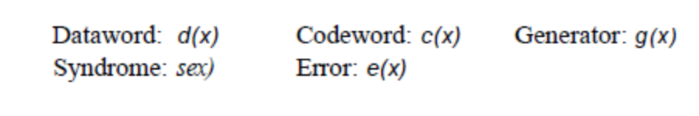
If sex) is not zero, then one or more bits is corrupted. However, if sex) is zero, either
no bit is corrupted or the decoder failed to detect any errors.
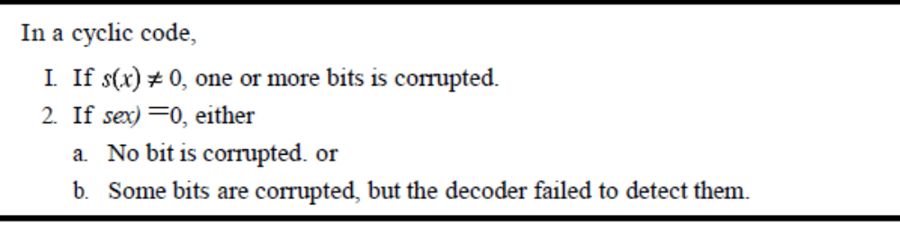b. Some bits are corrupted, but the decoder failed to detect them.

In our analysis we want to find the criteria that must be imposed on the generator,
g(x) to detect the type of error we especially want to be detected. Let us first find the
relationship among the sent codeword, error, received codeword, and the generator.
We can say
Received codeword =c(x) + e(x)
In other words, the received codeword is the sum of the sent codeword and the error.
The receiver divides the received codeword by g(x) to get the syndrome. We can write
this as
Received codeword = c(x) + e(x)
g(x) g(x) g(x)
The first term at the right-hand side of the equality does not have a remainder
(according to the definition of codeword). So the syndrome is actually the remainder of
the second term on the right-hand side. If this term does not have a remainder (syndrome
=0), either e(x) is 0 or e(x) is divisible by g(x). We do not have to worry about
the first case (there is no error); the second case is very important. Those errors that are
divisible by g(x) are not caught.
In a cyclic code, those e(x) errors that are divisible by g(x) are not caught.
Let us show some specific errors and see how they can be caught by a welldesigned
g(x).
Single-Bit Error
What should be the structure of g(x) to guarantee the detection of a single-bit error? A
single-bit error is e(x) =xi, where i is the position of the bit. If a single-bit error is caught,
then xi is not divisible by g(x). (Note that when we say not divisible, we mean that there
is a remainder.) If g(x) ha~ at least two terms (which is normally the case) and the coefficient
of xO is not zero (the rightmost bit is 1), then e(x) cannot be divided by g(x).
H the generator has more than one term and the coefficient ofxO is 1,
all single errors can be caught.
Example 10.15
Which of the following g(x) values guarantees that a single-bit error is caught? For each case,
what is the error that cannot be caught?
a. x + 1
b. x3
c. 1
SECTION 10.4 CYCLIC CODES 295
Solution
a. No xi can be divisible by x + 1. In other words, xi/ex + 1) always has a remainder. So the
syndrome is nonzero. Any single-bit error can be caught.
b. If i is equal to or greater than 3, xi is divisible by g(x). The remainder of xi/x3 is zero, and
the receiver is fooled into believing that there is no error, although there might be one.
Note that in this case, the corrupted bit must be in position 4 or above. All single-bit
errors in positions I to 3 are caught.
c. All values of i make j divisible by g(x). No single-bit error can be caught. In addition, this
g(x) is useless because it means the codeword is just the dataword augmented withn - k zeros.
Two Isolated Single-Bit Errors
Now imagine there are two single-bit isolated errors. Under what conditions can this
type of error be caught? We can show this type of error as e(x) =: xl + xi. The values of i
and j define the positions of the errors, and the difference j - i defines the distance
between the two errors, as shown in Figure 10.23.
Figure 10.23 Representation o/two isolated single-bit errors using polynomials
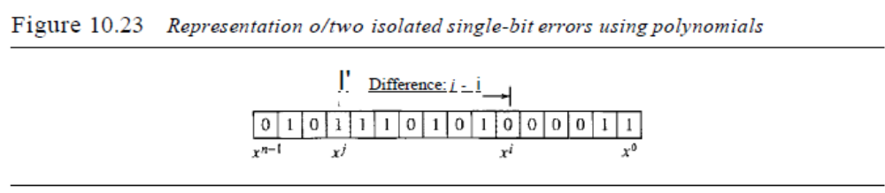
We can write e(x) = 1(xj - i + 1). If g(x) has more than one term and one term is xo, it
cannot divide 1, as we saw in the previous section. So if g(x) is to divide e(x), it must divide
xj - i + 1. In other words, g(x) must not divide Y! + 1, where t is between 0 and n - 1. However,
t=:O is meaningless and t = I is needed as we will see later. This means t should be between
2andn-1.
H a generator cannot divide r + 1 (t between 0 and n - 1),
then all isolated double errors can be detected.
Example 10.16
Find the status of the following generators related to two isolated, single-bit errors.
a. x+ 1
b. x4 + I
c. x7 + x6 + 1
d. x ls +xI4 +1
Solution
a. This is a very poor choice for a generator. Any two errors next to each other cannot be detected.
b. This generator cannot detect two errors that are four positions apart. The two errors can
be anywhere, but if their distance is 4, they remain undetected.
c. This is a good choice for this purpose.
d. This polynomial cannot divide any error of typext + 1 if t is less than 32,768. This means
that a codeword with two isolated errors that are next to each other or up to 32,768 bits
apart can be detected by this generator.
Odd Numbers of Errors
A generator with a factor of x + 1 can catch all odd numbers of errors. This means that
we need to make x + 1 a factor of any generator. Note that we are not saying that the
generator itself should be x + 1; we are saying that it should have a factor of x + 1. If it
is only x + 1, it cannot catch the two adjacent isolated errors (see the previous section).
For example, x4 + x2 + X + 1 can catch all odd-numbered errors since it can be written
as a product of the two polynomials x + 1 and x3 + x2 + 1.
A generator that contains a factor ofx + 1 can detect all odd-numbered errors.
Burst Errors
Now let us extend our analysis to the burst error, which is the most important of all. A
burst error is of the form e(x) =eJ + ... + xi). Note the difference between a burst error
and two isolated single-bit errors. The first can have two terms or more; the second can
only have two terms. We can factor out xi and write the error as xi(xJ-i + ... + 1). If our
generator can detect a single error (minimum condition for a generator), then it cannot
divide xi. What we should worry about are those generators that divide xJ-i + ... + 1. In
other words, the remainder of (xJ-i + ... + 1)/(xr + ... + 1) must not be zero. Note that
the denominator is the generator polynomial. We can have three cases:
1. If j - i < r, the remainder can never be zero. We can write j - i =L - 1, where L is
the length of the error. So L - 1 < r or L < r + 1 or L :::;: r. This means all burst errors
with length smaller than or equal to the number of check bits r will be detected.
2. In some rare cases, if j - i = r, or L = r + 1, the syndrome is 0 and the error is undetected.
It can be proved that in these cases, the probability of undetected burst error of
length r + 1 is (ll2r-l . For example, if our generator is x l4 + ~ + 1, in which r =14, a
burst error of length L =15 can slip by undetected with the probability of (1/2)14-1 or
almost 1 in 10,000.
3. In some rare cases, if j - i > r, or L > r + 1, the syndrome is 0 and the error is undetected.
It can be proved that in these cases, the probability of undetected burst error
of length greater than r + 1 is (112t For example, if our generator is x14 + x3 + 1, in
which r =14, a burst error of length greater than 15 can slip by undetected with the
probability of (112)14 or almost 1 in 16,000 cases.
o All burst errors with L ::::; r will be detected.
o All burst errors with L =r + 1 will be detected with probability 1 - (112/-1•
o All burst errors with L > r + 1 will be detected with probability 1- (1/2[.
Example 10.17
Find the suitability of the following generators in relation to burst errors of different lengths.
a. x6 + 1
b. x I8 + x7 + x + 1
c. x32+~3+x7+1
Solution
a. This generator can detect all burst errors with a length less than or equal to 6 bits; 3 out
of 100 burst errors with length 7 will slip by; 16 out of 1000 burst errors of length 8 or
more will slip by.
b. This generator can detect all burst errors with a length less than or equal to 18 bits; 8 out
of 1 million burst errors with length 19 will slip by; 4 out of I million burst errors of
length 20 or more will slip by.
c. This generator can detect all burst errors with a length less than or equal to 32 bits; 5 out
of 10 billion burst errors with length 33 will slip by; 3 out of 10 billion burst errors of
length 34 or more will slip by.
Summary
We can summarize the criteria for a good polynomial generator:
A good polynomial generator needs to have the following characteristics:
1. It should have at least two terms.
2. The coefficient of the term xO should be 1.
3. It should not divide Xl + 1, for t between 2 and n - 1.
4. It should have the factor x + 1.
Standard Polynomials
Some standard polynomials used by popular protocols for eRe generation are shown
in Table 10.7.
Table 10.7 Standard polynomials
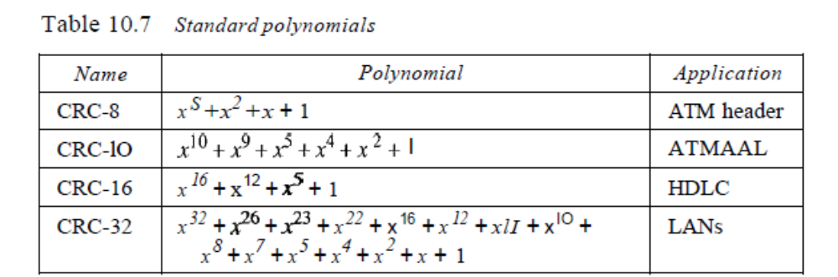Advantages of Cyclic Codes
We have seen that cyclic codes have a very good performance in detecting single-bit
errors, double errors, an odd number of errors, and burst errors. They can easily be
implemented in hardware and software. They are especially fast when implemented in
hardware. This has made cyclic codes a good candidate for many networks.
Other Cyclic Codes
The cyclic codes we have discussed in this section are very simple. The check bits and
syndromes can be calculated by simple algebra. There are, however, more powerful
polynomials that are based on abstract algebra involving Galois fields. These are beyond
298 CHAPTER 10 ERROR DETECTIONAND CORRECTION
the scope of this book. One of the most interesting of these codes is the Reed-Solomon
code used today for both detection and correction.
10.5 CHECKSUM
The last error detection method we discuss here is called the checksum. The checksum
is used in the Internet by several protocols although not at the data link layer. However,
we briefly discuss it here to complete our discussion on error checking.
Like linear and cyclic codes, the checksum is based on the concept of redundancy.
Several protocols still use the checksum for error detection as we will see in future
chapters, although the tendency is to replace it with a CRe. This means that the CRC is
also used in layers other than the data link layer.
Idea
The concept of the checksum is not difficult. Let us illustrate it with a few examples.
Example 10.18
Suppose our data is a list of five 4-bit numbers that we want to send to a destination. In addition
to sending these numbers, we send the sum of the numbers. For example, if the set of numbers is
(7, 11, 12, 0, 6), we send (7, 11, 12,0,6,36), where 36 is the sum of the original numbers. The
receiver adds the five numbers and compares the result with the sum. If the two are the same,
the receiver assumes no error, accepts the five numbers, and discards the sum. Otherwise, there is
an error somewhere and the data are not accepted.
Example 10.19
We can make the job of the receiver easier if we send the negative (complement) of the sum,
called the checksum. In this case, we send (7, 11, 12,0,6, -36). The receiver can add all the numbers
received (including the checksum). If the result is 0, it assumes no error; otherwise, there is
an error.
One's Complement
The previous example has one major drawback. All of our data can be written as a 4-bit
word (they are less than 15) except for the checksum. One solution is to use one's complement
arithmetic. In this arithmetic, we can represent unsigned numbers between 0
and 2n - 1 using only n bits. t If the number has more than n bits, the extra leftmost bits
need to be added to the n rightmost bits (wrapping). In one's complement arithmetic, a
negative number can be represented by inverting all bits (changing a 0 to a 1 and a 1 to
a 0). This is the same as subtracting the number from 2n - 1.
Example 10.20
How can we represent the number 21 in one's complement arithmetic using only four bits?
t Although one's complement can represent both positive and negative numbers, we are concerned only with
unsigned representation here.
SECTION 10.5 CHECKSUM 299
Solution
The number 21 in binary is 10101 (it needs five bits). We can wrap the leftmost bit and add it to
the four rightmost bits. We have (0101 + 1) = 0110 or 6.
Example 10.21
How can we represent the number -6 in one's complement arithmetic using only four bits?
Solution
In one's complement arithmetic, the negative or complement of a number is found by inverting
all bits. Positive 6 is 0110; negative 6 is 100I. If we consider only unsigned numbers, this is 9. In
other words, the complement of 6 is 9. Another way to find the complement of a number in one's
complement arithmetic is to subtract the numberfrom 2n - I (16 - 1 in this case).
Example 10.22
Let us redo Exercise 10.19 using one's complement arithmetic. Figure 10.24 shows the process at
the sender and at the receiver. The sender initializes the checksum to 0 and adds all data items and
the checksum (the checksum is considered as one data item and is shown in color). The result is
36. However, 36 cannot be expressed in 4 bits. The extra two bits are wrapped and added with
the sum to create the wrapped sum value 6. In the figure, we have shown the details in binary. The
sum is then complemented, resulting in the checksum value 9 (15 - 6 = 9). The sender now sends
six data items to the receiver including the checksum 9. The receiver follows the same procedure
as the sender. It adds all data items (including the checksum); the result is 45. The sum is
wrapped and becomes 15. The wrapped sum is complemented and becomes O. Since the value of
the checksum is 0, this means that the data is not corrupted. The receiver drops the checksum and
keeps the other data items. If the checksum is not zero, the entire packet is dropped.
Figure 10.24
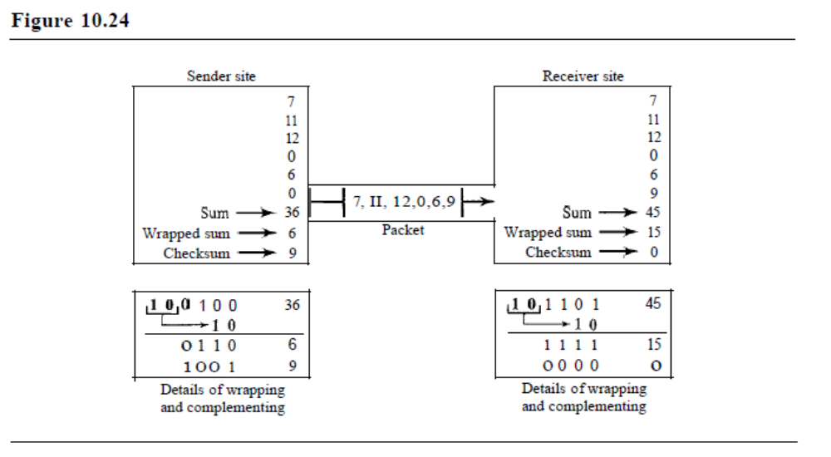Internet Checksum
Traditionally, the Internet has been using a 16-bit checksum. The sender calculates the
checksum by following these steps.

Sender site:
1. The message is divided into 16-bit words.
2. The value of the checksum word is set to O.
3. All words including the checksum are added ushtg one's complement addition.
4. The sum is complemented and becomes the checksum.
5. The checksum is sent with the data.
The receiver uses the following steps for error detection.
Receiver site:
1. The message (including checksum) is divided into 16-bit words.
2. All words are added using one's complement addition.
3. The sum is complemented and becomes the new checksum.
4. If the value of checksum is 0, the message is accepted; otherwise, it is rejected.
The nature of the checksum (treating words as numbers and adding and complementing
them) is well-suited for software implementation. Short programs can be written
to calculate the checksum at the receiver site or to check the validity of the message at
the receiver site.
Example 10.23
Let us calculate the checksum for a text of 8 characters ("Forouzan"). The text needs to be divided
into 2-byte (l6-bit) words. We use ASCII (see Appendix A) to change each byte to a 2-digit hexadecimal
number. For example, F is represented as Ox46 and 0 is represented as Ox6F. Figure 10.25
shows how the checksum is calculated at the sender and receiver sites. In part a of the figure,
the value of partial sum for the first column is Ox36. We keep the rightmost digit (6) and insert the
Figure 10.25
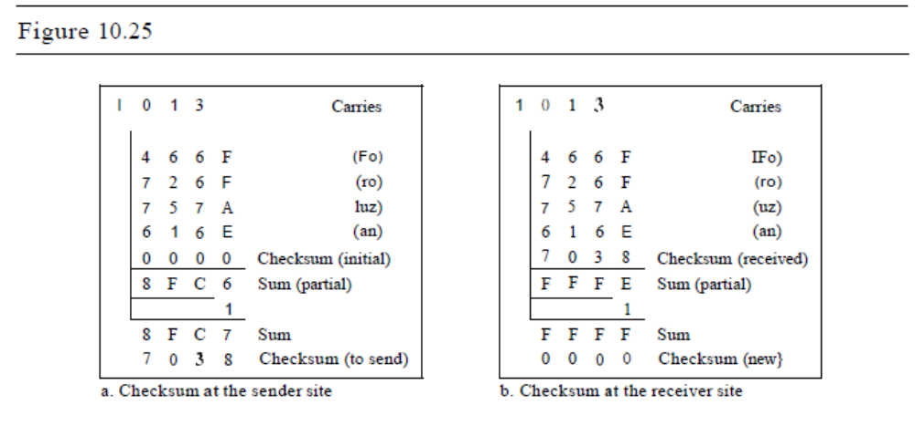 leftmost dight (3) as the carry in the second column. The process is repeated for each column.
Hexadecimal numbers are reviewed in Appendix B.
Note that if there is any corruption, the checksum recalculated by the receiver is not all as.
We leave this an exercise.
Performance
The traditional checksum uses a small number of bits (16) to detect errors in a message
of any size (sometimes thousands of bits). However, it is not as strong as the CRC in
error-checking capability. For example, if the value of one word is incremented and the
value of another word is decremented by the same amount, the two errors cannot be
detected because the sum and checksum remain the same. Also if the values of several
words are incremented but the total change is a multiple of 65535, the sum and the
checksum does not change, which means the errors are not detected. Fletcher and Adler
have proposed some weighted checksums, in which each word is multiplied by a number
(its weight) that is related to its position in the text. This will eliminate the first
problem we mentioned. However, the tendency in the Internet, particularly in designing
new protocols, is to replace the checksum with a CRC.

11.1 FRAMING
Data transmission in the physical layer means moving bits in the form of a signal from
the source to the destination. The physical layer provides bit synchronization to ensure
that the sender and receiver use the same bit durations and timing.
The data link layer, on the other hand, needs to pack bits into frames, so that each
frame is distinguishable from another. Our postal system practices a type of framing.
The simple act of inserting a letter into an envelope separates one piece of information
from another; the envelope serves as the delimiter. In addition, each envelope defines
the sender and receiver addresses since the postal system is a many-to-many carrier
facility.
Framing in the data link layer separates a message from one source to a destination,
or from other messages to other destinations, by adding a sender address and a
destination address. The destination address defines where the packet is to go; the sender
address helps the recipient acknowledge the receipt.
Although the whole message could be packed in one frame, that is not normally
done. One reason is that a frame can be very large, making flow and error control very
inefficient. When a message is carried in one very large frame, even a single-bit error
would require the retransmission of the whole message. When a message is divided
into smaller frames, a single-bit error affects only that small frame.
Fixed-Size Framing
Frames can be of fixed or variable size. In fixed-size framing, there is no need for defining
the boundaries of the frames; the size itself can be used as a delimiter. An example
of this type of framing is the ATM wide-area network, which uses frames of fixed size
called cells. We discuss ATM in Chapter 18.
Variable-Size Framing
Our main discussion in this chapter concerns variable-size framing, prevalent in localarea
networks. In variable-size framing, we need a way to define the end of the frame
and the beginning of the next. Historically, two approaches were used for this purpose:
a character-oriented approach and a bit-oriented approach.
Character-Oriented Protocols
In a character-oriented protocol, data to be carried are 8-bit characters from a coding
system such as ASCII (see Appendix A). The header, which normally carries the source
and destination addresses and other control information, and the trailer, which carries
error detection or error correction redundant bits, are also multiples of 8 bits. To separate
one frame from the next, an 8-bit (I-byte) flag is added at the beginning and the end of a
frame. The flag, composed of protocol-dependent special characters, signals the start or
end of a frame. Figure 11.1 shows the format of a frame in a character-oriented protocol.
Figure 11.1 Aframe in a character-oriented protocol
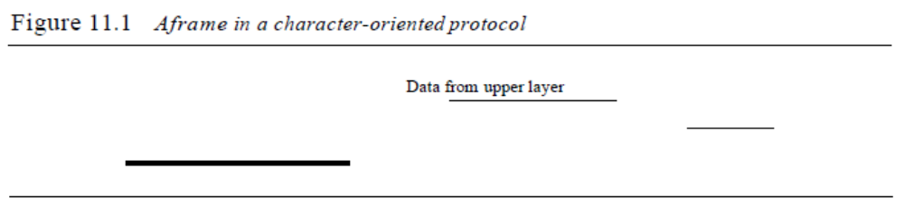Data from upper layer
Character-oriented framing was popular when only text was exchanged by the data
link layers. The flag could be selected to be any character not used for text communication.
Now, however, we send other types of information such as graphs, audio, and
video. Any pattern used for the flag could also be part of the information. If this happens,
the receiver, when it encounters this pattern in the middle of the data, thinks it has
reached the end of the frame. To fix this problem, a byte-stuffing strategy was added to
SECTION 11.1 FRAMING 309
character-oriented framing. In byte stuffing (or character stuffing), a special byte is
added to the data section of the frame when there is a character with the same pattern as
the flag. The data section is stuffed with an extra byte. This byte is usually called the
escape character (ESC), which has a predefined bit pattern. Whenever the receiver
encounters the ESC character, it removes it from the data section and treats the next
character as data, not a delimiting flag.
Byte stuffing by the escape character allows the presence of the flag in the data section
of the frame, but it creates another problem. What happens if the text contains one or
more escape characters followed by a flag? The receiver removes the escape character,
but keeps the flag, which is incorrectly interpreted as the end of the frame. To solve this
problem, the escape characters that are part of the text must also be marked by another
escape character. In other words, if the escape character is part of the text, an extra one is
added to show that the second one is part of the text. Figure 11.2 shows the situation.
Figure 11.2 Byte stuffing and unstuffing
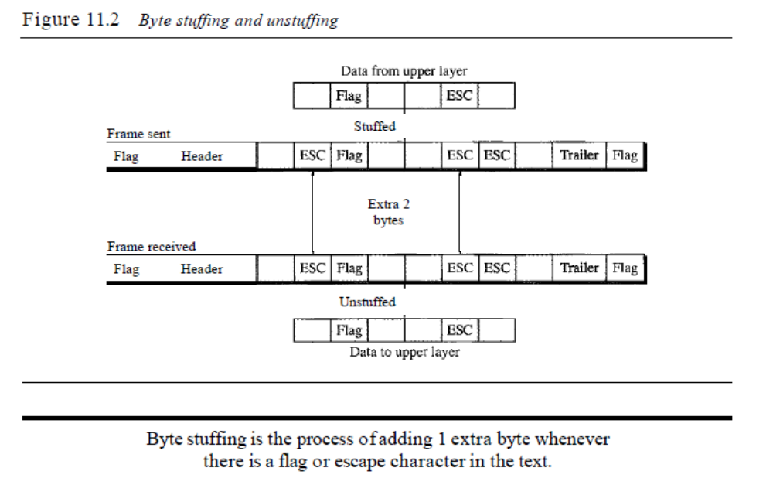
Character-oriented protocols present another problem in data communications.
The universal coding systems in use today, such as Unicode, have 16-bit and 32-bit
characters that conflict with 8-bit characters. We can say that in general, the tendency is
moving toward the bit-oriented protocols that we discuss next.
Bit-Oriented Protocols
In a bit-oriented protocol, the data section of a frame is a sequence of bits to be interpreted
by the upper layer as text, graphic, audio, video, and so on. However, in addition
to headers (and possible trailers), we still need a delimiter to separate one frame from
the other. Most protocols use a special 8-bit pattern flag 01111110 as the delimiter to
define the beginning and the end of the frame, as shown in Figure 11.3.
310 CHAPTER 11 DATA LINK CONTROL
Figure 11.3 A frame in a bit-oriented protocol
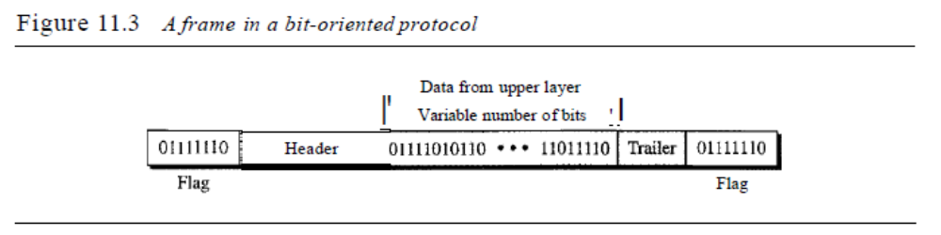This flag can create the same type of problem we saw in the byte-oriented protocols.
That is, if the flag pattern appears in the data, we need to somehow inform the
receiver that this is not the end of the frame. We do this by stuffing 1 single bit (instead
of I byte) to prevent the pattern from looking like a flag. The strategy is called bit
stuffing. In bit stuffing, if a 0 and five consecutive I bits are encountered, an extra 0 is
added. This extra stuffed bit is eventually removed from the data by the receiver. Note
that the extra bit is added after one 0 followed by five 1s regardless of the value of the
next bit. This guarantees that the flag field sequence does not inadvertently appear in
the frame.
Bit stuffing is the process of adding one extra 0 whenever five consecutive 18 follow a 0
in the data, so that the receiver does not mistake the pattern 0111110 for a flag.
Figure 11.4 shows bit stuffing at the sender and bit removal at the receiver. Note that
even if we have a 0 after five 1s, we still stuff a O. The 0 will be removed by the receiver.
Figure 11.4 Bit stuffing and unstuffing
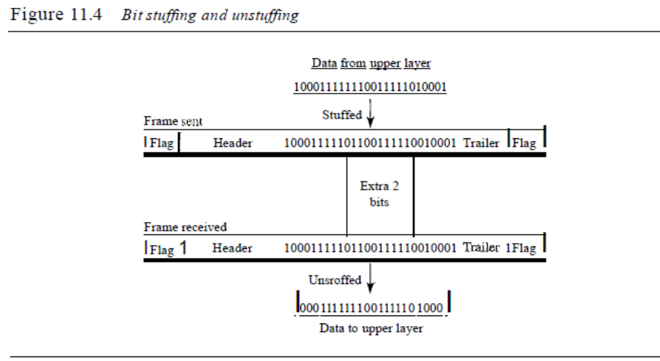
Data to upper layer
This means that if the flaglike pattern 01111110 appears in the data, it will change
to 011111010 (stuffed) and is not mistaken as a flag by the receiver. The real flag 01111110
is not stuffed by the sender and is recognized by the receiver.
Stop-and-Wait Protocol
If data frames arrive at the receiver site faster than they can be processed, the frames
must be stored until their use. Normally, the receiver does not have enough storage
space, especially if it is receiving data from many sources. This may result in either the
discarding of frames or denial of service. To prevent the receiver from becoming overwhelmed
with frames,we somehow need to tell the sender to slow down. There must be
feedback from the receiver to the sender.
The protocol we discuss now is called the Stop-and-Wait Protocol because the
sender sends one frame, stops until it receives confirmation from the receiver (okay to
go ahead), and then sends the next frame. We still have unidirectional communication
for data frames, but auxiliary ACK frames (simple tokens of acknowledgment) travel
from the other direction. We add flow control to our previous protocol.
Design
Figure 11.8 illustrates the mechanism. Comparing this figure with Figure 11.6, we can
see the traffic on the forward channel (from sender to receiver) and the reverse channel.
At any time, there is either one data frame on the forward channel or one ACK frame on
the reverse channel. We therefore need a half-duplex link.
Algorithms
Algorithm 11.3 is for the sender site.
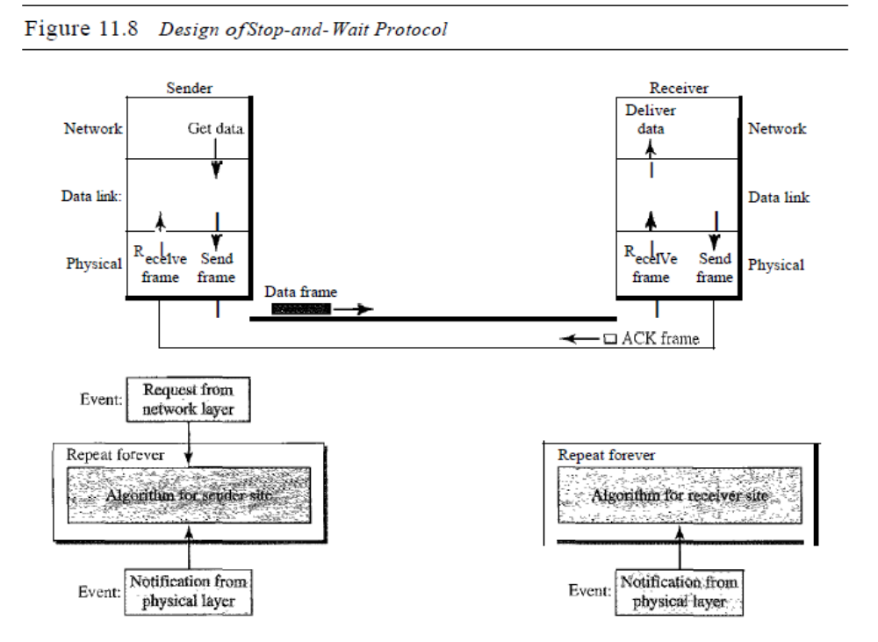
Figure 11.8 Design ofStop-and- Wait Protocol
Sender Receiver
Network
Data link:
Physical
Deliver
Gettata data ..
T I
.. I ~ I
R I. T R I. ,T
ecelve Send ecelVe Send
frame frame frame frame
Data frame
I ~~ I
~DACKframe
Network
Data link
Physical
Repeat forever
Algorithm 11.3 Sender-site algorithm for Stop-and- Wait Protocol
Iwhile (true)
canSend = true
II Sleep until an event occurs
AND canSend}
II Sleep until an event occurs
/1 An ACK has arrived
I/Send the data frame
I/cannot send until ACK arrives
IIRepeat forever
IIAllow the first frame to go
ReceiveFrame(); I/Receive the ACK £r~e
canSend ~ true;
GetDataO i
MakeFrame();
SendFrame()i
canSend = false;
}
}
WaitForEvent()i
if (Event (ArrivalNotification)
{
{
WaitForEvent()i
if (Event (RequestToSend)
{
1
2
3
4
5
6
7
8
9
10
11
12
13
14
15
16
17
18 }
Analysis Here two events can occur: a request from the network layer or an arrival notification
from the physical layer. The responses to these events must alternate. In other words, after a
frame is sent, the algorithm must ignore another network layer request until that frame is
SECTION 1I.4 NOISELESS CHANNELS 317
acknowledged. We know that two arrival events cannot happen one after another because the
channel is error-free and does not duplicate the frames. The requests from the network layer,
however, may happen one after another without an arrival event in between. We need somehow to
prevent the immediate sending of the data frame. Although there are several methods, we have
used a simple canSend variable that can either be true or false. When a frame is sent, the variable
is set to false to indicate that a new network request cannot be sent until canSend is true. When an
ACK is received, canSend is set to true to allow the sending of the next frame.
Algorithm 11.4 shows the procedure at the receiver site.
Algorithm 11.4 Receiver-site algorithm for Stop-and-Wait Protocol
WaitForEvent(); II Sleep until an event occurf
if(Event(ArrivalNotification)} IIData frame arrives
{
/IDeliver data to network layex
IISend an ACK frame
IIRepeat forever
ReceiveFrame(};
ExtractData(}i
Deliver(data};
SendFrame();
}
1 while (true)
2 {
3
4
5
6
7
8
9
10
11 }
Analysis This is very similar to Algorithm 11.2 with one exception. After the data frame
arrives, the receiver sends an ACK frame (line 9) to acknowledge the receipt and allow the sender
to send the next frame.
Example 11.2
Figure 11.9 shows an example of communication using this protocol. It is still very simple. The
sender sends one frame and waits for feedback from the receiver. When the ACK arrives, the
sender sends the next frame. Note that sending two frames in the protocol involves the sender in
four events and the receiver in two events.
Figure 11.9 Flow diagramfor Example 1I.2
Sender
INA]
Receiver
rIJ
Arrival
Frame
Arrival :
I
Request
ReqUest~~ :
I Arrival
I
1. AC'i..
Arrival' I
• 1
t t
Time Time
318 CHAPTER 11 DATA LINK CONTROL
11.5 NOISY CHANNELS
Although the Stop-and-Wait Protocol gives us an idea of how to add flow control to its
predecessor, noiseless channels are nonexistent. We can ignore the error (as we sometimes
do), or we need to add error control to our protocols. We discuss three protocols
in this section that use error control.
Stop-and-Wait Automatic Repeat Request
Our first protocol, called the Stop-and-Wait Automatic Repeat Request (Stop-andWait
ARQ), adds a simple error control mechanism to the Stop-and-Wait Protocol. Let
us see how this protocol detects and corrects errors.
To detect and correct corrupted frames, we need to add redundancy bits to our data
frame (see Chapter 10). When the frame arrives at the receiver site, it is checked and if
it is corrupted, it is silently discarded. The detection of errors in this protocol is manifested
by the silence of the receiver.
Lost frames are more difficult to handle than corrupted ones. In our previous protocols,
there was no way to identify a frame. The received frame could be the correct one,
or a duplicate, or a frame out of order. The solution is to number the frames. When the
receiver receives a data frame that is out of order, this means that frames were either
lost or duplicated.
The comlpted and lost frames need to be resent in this protocol. If the receiver does
not respond when there is an error, how can the sender know which frame to resend? To
remedy this problem, the sender keeps a copy of the sent frame. At the same time, it starts
a timer. If the timer expires and there is no ACK for the sent frame, the frame is resent, the
copy is held, and the timer is restarted. Since the protocol uses the stop-and-wait mechanism,
there is only one specific frame that needs an ACK even though several copies of
the same frame can be in the network.
Error correction in Stop-and-Wait ARQ is done by keeping a copy of the sent frame
and retransmitting of the frame when the timer expires.
Since an ACK frame can also be corrupted and lost, it too needs redundancy bits
and a sequence number. The ACK frame for this protocol has a sequence number field.
In this protocol, the sender simply discards a corrupted ACK frame or ignores an
out-of-order one.
Sequence Numbers
As we discussed, the protocol specifies that frames need to be numbered. This is done
by using sequence numbers. A field is added to the data frame to hold the sequence
number of that frame.
One important consideration is the range of the sequence numbers. Since we want
to minimize the frame size, we look for the smallest range that provides unambiguous
SECTION 11.5 NOISY CHANNELS 319
communication. The sequence numbers of course can wrap around. For example, if we
decide that the field is m bits long, the sequence numbers start from 0, go to 2m - 1, and
then are repeated.
Let us reason out the range of sequence numbers we need. Assume we have used x as
a sequence number; we only need to use x + 1 after that. There is no need for x + 2. To
show this, assume that the sender has sent the frame numbered x. Three things can happen.
1. The frame arrives safe and sound at the receiver site; the receiver sends an acknowledgment.
The acknowledgment arrives at the sender site, causing the sender to send
the next frame numbered x + 1.
2. The frame arrives safe and sound at the receiver site; the receiver sends an acknowledgment,
but the acknowledgment is corrupted or lost. The sender resends the frame
(numbered x) after the time-out. Note that the frame here is a duplicate. The receiver
can recognize this fact because it expects frame x + I but frame x was received.
3. The frame is corrupted or never arrives at the receiver site; the sender resends the
frame (numbered x) after the time-out.
We can see that there is a need for sequence numbers x and x + I because the receiver
needs to distinguish between case 1 and case 2. But there is no need for a frame to be
numbered x + 2. In case 1, the frame can be numbered x again because frames x and x + 1
are acknowledged and there is no ambiguity at either site. In cases 2 and 3, the new frame
is x + I, not x + 2. If only x and x + 1 are needed, we can let x = 0 and x + I == 1. This
means that the sequence is 0, I, 0, I, 0, and so on. Is this pattern familiar? This is modulo-2
arithmetic as we saw in Chapter 10.
In Stop-and-Wait ARQ~ we use sequence numbers to number the frames.
The sequence numbers are based on modul0-2 arithmetic.
Acknowledgment Numbers
Since the sequence numbers must be suitable for both data frames and ACK frames, we
use this convention: The acknowledgment numbers always announce the sequence
number of the next frame expected by the receiver. For example, if frame 0 has arrived
safe and sound, the receiver sends an ACK frame with acknowledgment 1 (meaning
frame 1 is expected next). If frame 1 has arrived safe and sound, the receiver sends an
ACK frame with acknowledgment 0 (meaning frame 0 is expected).
In Stop-and-WaitARQ~the acknowledgment number always announces in
modul0-2 arithmetic the sequence number of the next frame expected.
Design
Figure 11.10 shows the design of the Stop-and-WaitARQ Protocol. The sending device
keeps a copy of the last frame transmitted until it receives an acknowledgment for that
frame. A data frames uses a seqNo (sequence number); an ACK frame uses an ackNo
(acknowledgment number). The sender has a control variable, which we call Sn (sender,
next frame to send), that holds the sequence number for the next frame to be sent (0 or 1).
320 CHAPTER 11 DATA LINK CONTROL
Figure 11.10 Design ofthe Stop-and-WaitARQ Protocol
SII Next frame
J;0 send
r---r--- ---r---,
'L 0'101'0'··· ~___ _ __ 1 J
Sender Receiver
Network
Data link
Physical
Data frame ACKframe Deliver '1* *" Get data - rr- data
I seqNo ackNo ...
T I
• I ... I
R I. T R I. T
ecelve Send ecelve Send
frame frame frame frame
I ! liM ~ I
~~
Network
Data link
Physical
Event:I Request from I network layer
I Repeat forever t 0
. ~- - ~- -
,.C; ;~AIgmnhm for sender'site .- Time-out I
..;._,,,:,,:,,'.:" , Event:
1..
I
E t: INotification from I ven. physical layer
Repeat forever
." .'
~-. -- .AJ:go.rlt,bm for receiver Site .. . .
1..
I
E t: INotification from I ven. PhyS'lCallayer
The receiver has a control variable, which we call Rn (receiver, next frame expected),
that holds the number of the next frame expected. When a frame is sent, the value of Sn
is incremented (modulo-2), which means if it is 0, it becomes 1 and vice versa. When a
frame is received, the value of Rn is incremented (modulo-2), which means if it is 0, it
becomes 1 and vice versa. Three events can happen at the sender site; one event can
happen at the receiver site. Variable Sn points to the slot that matches the sequence
number of the frame that has been sent, but not acknowledged; Rn points to the slot that
matches the sequence number of the expected frame.
Algorithms
Algorithm 11.5 is for the sender site.
Algorithm 11.5 Sender-site algorithm for Stop-and- Wait ARQ
WaitForEvent();
1 n = 0;
2 anSend = true;
3 hile (true)
4 {
5
II Frame 0 should be sent first
II Allow the first request to go
II Repeat forever
II Sleep until an event occurs
SECTION 11.5 NOISY CHANNELS 321
//Resend a copy check
//Copy is not needed
II The timer expired
/ /The seqNo is Sn
//Keep copy
II Sleep
II An ACK has arrived
//Receive the ACE fram
80) / /Valid ACK
Stoptimer{};
PurgeFrame(Sn_l);
canSend = true;
}
ReceiveFrame(ackNo);
if(not corrupted AND ackNo
{
}
GetData () i
MakeFrame (Sn) ;
StoreFrame(Sn);
SendFrame(Sn) ;
StartTimerO;
Sn = Sn + 1;
canSend = false;
if (Event (TimeOUt)
{
StartTimer();
ResendFrame(Sn_l);
}
}
WaitForEvent();
if (Event (ArrivaINotification)
{
Algorithm 11.5 Sender-site algorithm for Stop-and-Wait ARQ (continued)
6 if (Event (RequestToSend) AND canSend)
7 {
8
9
10
11
12
13
14
15
16
17
18
19
20
21
22
23
24
25
26
27
28
29
30
31
32
33 }
Analysis We first notice the presence of Sn' the sequence number of the next frame to be sent.
This variable is initialized once (line 1), but it is incremented every time a frame is sent (line 13) in
preparation for the next frame. However, since this is modulo-2 arithmetic, the sequence numbers are
0, 1,0, 1, and so on. Note that the processes in the first event (SendFrame, StoreFrame, and PurgeFrame)
use an Sn defining the frame sent out. We need at least one buffer to hold this frame until
we are sure that it is received safe and sound. Line 10 shows that before the frame is sent, it is stored.
The copy is used for resending a corrupt or lost frame. We are still using the canSend variable to prevent
the network layer from making a request before the previous frame is received safe and sound. If
the frame is not corrupted and the ackNo of theACK frame matches the sequence number of the next
frame to send, we stop the timer and purge the copy of the data frame we saved. Otherwise, we just
ignore this event and wait for the next event to happen. After each frame is sent, a timer is started.
When the timer expires (line 28), the frame is resent and the timer is restarted.
Algorithm 11.6 shows the procedure at the receiver site.
Algorithm 11.6 Receiver-site algorithm for Stop-and-WaitARQ Protocol
1 = 0;
2 hile (true)
3 {
4 WaitForEvent();
II Frame 0 expected to arrive firs
II Sleep until an event occurs
322 CHAPTER 11 DATA LINK CONTROL
Algorithm 11.6 Receiver-site algorithm for Stop-and- WaitARQ Protocol (continued)
5
6
7
8
9
10
11
12
13
14
15
16
17
18 }
if(Event(Arriva1Notification»
{
ReceiveFrame()i
if(corrupted(frame»i
sleep () i
if (seqNo ;;;;:;;;; Rn)
{
ExtractData();
De1iverData()i
Ru ;;;; Ru + 1;
}
SendFrame (Rn) ;
}
//Data frame arrives
//Valid data frame
//Deliver data
//Send an ACK
Analysis This is noticeably different from Algorithm 11.4. First, all arrived data frames that are
corrupted are ignored. If the seqNo of the frame is the one that is expected (Rn ), the frame is
accepted, the data are delivered to the network layer, and the value of Rn is incremented. However,
there is one subtle point here. Even if the sequence number of the data frame does not match
the next frame expected, an ACK is sent to the sender. This ACK, however, just reconfirms the
previous ACK instead of confirming the frame received. This is done because the receiver
assumes that the previous ACK might have been lost; the receiver is sending a duplicate frame.
The resent ACK may solve the problem before the time-out does it.
Example 11.3
Figure 11.11 shows an example of Stop-and-Wait ARQ. Frame a is sent and acknowledged.
Frame 1 is lost and resent after the time-out. The resent frame 1 is acknowledged and the timer
stops. Frame ais sent and acknowledged, but the acknowledgment is lost. The sender has no idea
if the frame or the acknowledgment is lost, so after the time-out, it resends frame 0, which is
acknowledged.
Efficiency
The Stop-and-WaitARQ discussed in the previous section is very inefficient if our channel
is thick and long. By thick, we mean that our channel has a large bandwidth; by long,
we mean the round-trip delay is long. The product of these two is called the bandwidthdelay
product, as we discussed in Chapter 3. We can think of the channel as a pipe. The
bandwidth-delay product then is the volume of the pipe in bits. The pipe is always there.
If we do not use it, we are inefficient. The bandwidth-delay product is a measure of the
number of bits we can send out of our system while waiting for news from the receiver.
Example 11.4
Assume that, in a Stop-and-Wait ARQ system, the bandwidth of the line is 1 Mbps, and 1 bit
takes 20 ms to make a round trip. What is the bandwidth-delay product? If the system data frames
are 1000 bits in length, what is the utilization percentage of the link?
Solution
The bandwidth-delay product is
SECTION 11.5 NOISY CHANNELS 323
Figure 11.11 Flow diagram for Example 11.3
Sender Receiver
Rn
~9_ET9Ihql!J Arrival
Rn
:~~[nQIrIqUJ Arrival
Rn
~o:-(:-o+o~-(: Arrival
1 __1__ :_J...!.1_!.._.!
Discard, duplicate
mI
I
I
ACK 1]
---------1
1
1
t
Time
5n
Request f9"1iJ-9J]~3iff~
Sn
Request @rU9I(~qn~
5n
Time-out f9"rtr9n_:_qff~
Stop
Start cp
Stop l
Stop
Start It
5"
Time-out It Time-out :-6 ~ i+f ~ restart ,__ !._l£J__ '_0_i1"_1_-'1
Time-out
restart
The system can send 20,000 bits during the time it takes for the data to go from the sender to the
receiver and then back again. However, the system sends only 1000 bits. We can say that the link
utilization is only 1000/20,000, or 5 percent. For this reason, for a link with a high bandwidth or
long delay, the use of Stop-and-Wait ARQ wastes the capacity of the link.
Example 11.5
What is the utilization percentage of the link in Example 11.4 if we have a protocol that can send
up to 15 frames before stopping and worrying about the acknowledgments?
Solution
The bandwidth-delay product is still 20,000 bits. The system can send up to 15 frames or
15,000 bits during a round trip. This means the utilization is 15,000/20,000, or 75 percent. Of
course, if there are damaged frames, the utilization percentage is much less because frames
have to be resent.
Pipelining
In networking and in other areas, a task is often begun before the previous task has ended.
This is known as pipelining. There is no pipelining in Stop-and-Wait ARQ because we
need to wait for a frame to reach the destination and be acknowledged before the next
frame can be sent. However, pipelining does apply to our next two protocols because
324 CHAPTER 11 DATA LINK CONTROL
several frames can be sent before we receive news about the previous frames. Pipelining
improves the efficiency of the transmission if the number of bits in transition is large with
respect to the bandwidth-delay product.
Multiple Access

In Chapter 11 we discussed data link control, a mechanism which provides a link with
reliable communication. In the protocols we described, we assumed that there is an
available dedicated link (or channel) between the sender and the receiver. This assumption
mayor may not be true. If, indeed, we have a dedicated link, as when we connect
to the Internet using PPP as the data link control protocol, then the assumption is true
and we do not need anything else.
On the other hand, if we use our cellular phone to connect to another cellular phone,
the channel (the band allocated to the vendor company) is not dedicated. A person a few
feet away from us may be using the same channel to talk to her friend.
We can consider the data link layer as two sublayers. The upper sublayer is responsible
for data link control, and the lower sublayer is responsible for resolving access to the
shared media. If the channel is dedicated, we do not need the lower sublayer. Figure 12.1
shows these two sublayers in the data link layer.
Figure 12.1 Data link layer divided into two functionality-oriented sublayers
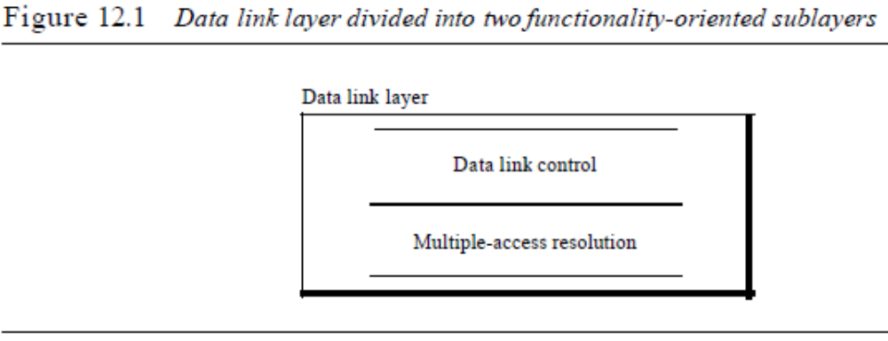
Data link layer
Data link control
Multiple-access resolution
We will see in Chapter 13 that the IEEE has actually made this division for LANs.
The upper sublayer that is responsible for flow and error control is called the logical
link control (LLC) layer; the lower sublayer that is mostly responsible for multipleaccess
resolution is called the media access control (MAC) layer.
When nodes or stations are connected and use a common link, called a multipoint
or broadcast link, we need a multiple-access protocol to coordinate access to the link.
The problem of controlling the access to the medium is similar to the rules of speaking
in an assembly. The procedures guarantee that the right to speak is upheld and ensure
that two people do not speak at the same time, do not interrupt each other, do not
monopolize the discussion, and so on.
The situation is similar for multipoint networks. Many formal protocols have been
devised to handle access to a shared lillie We categorize them into three groups. Protocols
belonging to each group are shown in Figure 12.2.
Figure 12.2 Taxonomy ofmultiple-access protocols discussed in this chapter
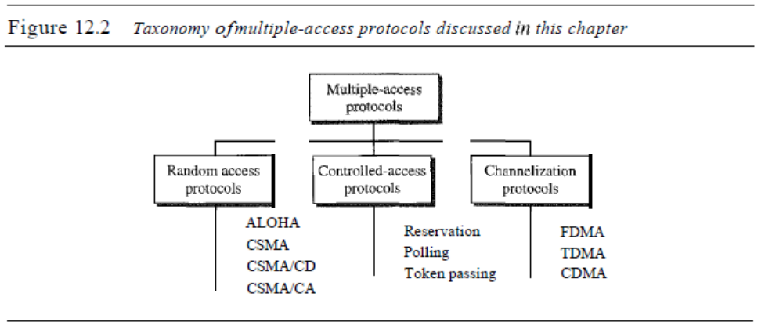
In random access or contention methods, no station is superior to another station and
none is assigned the control over another. No station permits, or does not permit,
another station to send. At each instance, a station that has data to send uses a procedure
defined by the protocol to make a decision on whether or not to send. This decision
depends on the state of the medium (idle or busy). In other words, each station can
transmit when it desires on the condition that it follows the predefined procedure,
including the testing of the state of the medium.
Two features give this method its name. First, there is no scheduled time for a station
to transmit. Transmission is random among the stations. That is why these methods are
called random access. Second, no rules specify which station should send next. Stations
compete with one another to access the medium. That is why these methods are also
called contention methods.
In a random access method, each station has the right to the medium without being
controlled by any other station. However, if more than one station tries to send, there is
an access conflict-collision-and the frames will be either destroyed or modified. To
avoid access conflict or to resolve it when it happens, each station follows a procedure
that answers the following questions:
o When can the station access the medium?
o What can the station do if the medium is busy?
o How can the station determine the success or failure of the transmission?
o What can the station do if there is an access conflict?
The random access methods we study in this chapter have evolved from a very
interesting protocol known as ALOHA, which used a very simple procedure called
multiple access (MA). The method was improved with the addition of a procedure that
forces the station to sense the medium before transmitting. This was called carrier sense
multiple access. This method later evolved into two parallel methods: carrier sense
multiple access with collision detection (CSMAlCD) and carrier sense multiple access
with collision avoidance (CSMA/CA). CSMA/CD tells the station what to do when a
collision is detected. CSMA/CA tries to avoid the collision.
ALOHA
ALOHA, the earliest random access method, was developed at the University of Hawaii
in early 1970. It was designed for a radio (wireless) LAN, but it can be used on any
shared medium.
It is obvious that there are potential collisions in this arrangement. The medium is
shared between the stations. When a station sends data, another station may attempt to
do so at the same time. The data from the two stations collide and become garbled.
Pure ALOHA
The original ALOHA protocol is called pure ALOHA. This is a simple, but elegant
protocol. The idea is that each station sends a frame whenever it has a frame to send.
However, since there is only one channel to share, there is the possibility of collision
between frames from different stations. Figure 12.3 shows an example of frame collisions
in pure ALOHA.
Figure 12.3 Frames in a pure ALOHA network
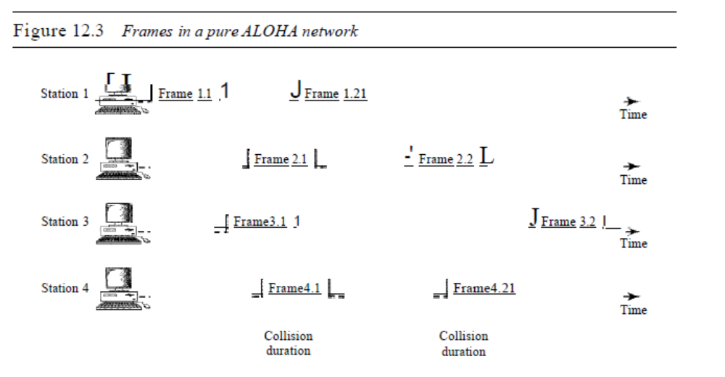There are four stations (unrealistic assumption) that contend with one another for
access to the shared channel. The figure shows that each station sends two frames; there
are a total of eight frames on the shared medium. Some of these frames collide because
multiple frames are in contention for the shared channel. Figure 12.3 shows that only
366 CHAPTER 12 MULTIPLE ACCESS
two frames survive: frame 1.1 from station 1 and frame 3.2 from station 3. We need to
mention that even if one bit of a frame coexists on the channel with one bit from
another frame, there is a collision and both will be destroyed.
It is obvious that we need to resend the frames that have been destroyed during
transmission. The pure ALOHA protocol relies on acknowledgments from the receiver.
When a station sends a frame, it expects the receiver to send an acknowledgment. If the
acknowledgment does not arrive after a time-out period, the station assumes that the
frame (or the acknowledgment) has been destroyed and resends the frame.
A collision involves two or more stations. If all these stations try to resend their
frames after the time-out, the frames will collide again. Pure ALOHA dictates that
when the time-out period passes, each station waits a random amount of time before
resending its frame. The randomness will help avoid more collisions. We call this time
the back-off time TB.
Pure ALOHA has a second method to prevent congesting the channel with retransmitted
frames. After a maximum number of retransmission attempts Kmax' a station
must give up and try later. Figure 12.4 shows the procedure for pure ALOHA based on
the above strategy.
Figure 12.4 Procedure for pure ALOHA protocol
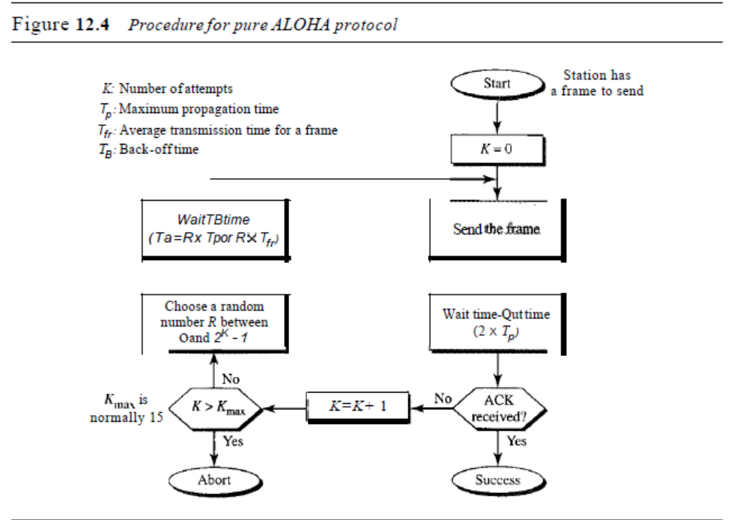The time-out period is equal to the maximum possible round-trip propagation delay,
which is twice the amount of time required to send a frame between the two most widely
separated stations (2 x Tp)' The back-off time TB is a random value that normally depends
on K (the number of attempted unsuccessful transmissions). The formula for TB depends on
the implementation. One common formula is the binary exponential back-off. In this
SECTION 12.1 RANDOMACCESS 367
method, for each retransmission, a multiplier in the range 0 to 2K - 1 is randomly chosen
and multiplied by Tp (maximum propagation time) or Trr (the average time required to
send out a frame) to find TB' Note that in this procedure, the range of the random numbers
increases after each collision. The value of Kmax is usually chosen as 15.
Example 12.1
The stations on a wireless ALOHA network are a maximum of 600 km apart. If we assume that
signals propagate at 3 x 108 mis, we find Tp = (600 x 105) / (3 x 108) = 2 ms. Now we can find the
value of TB for different values of K.
a. For K = 1, the range is {O, I}. The station needs to generate a random number with a
value of 0 or 1. This means that TB is either °ms (0 x 2) or 2 ms (l x 2), based on the
outcome of the random variable.
b. For K =2, the range is {O, 1, 2, 3}. This means that TB can be 0, 2, 4, or 6 ms, based on
the outcome of the random variable.
c. For K =3, the range is to, 1,2,3,4,5,6, 7}. This means that TB can be 0,2,4, ... , 14 ms,
based on the outcome of the random variable.
d. We need to mention that if K > 10, it is normally set to 10.
Vulnerable time Let us find the length of time, the vulnerable time, in which there
is a possibility of collision. We assume that the stations send fixed-length frames with
each frame taking Tfr S to send. Figure 12.5 shows the vulnerable time for station A.
Figure 12.5 Vulnerable time for pure ALOHA protocol

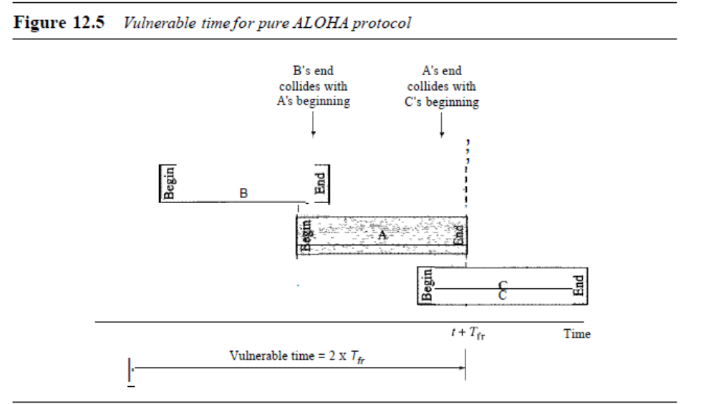Station A sends a frame at time t. Now imagine station B has already sent a frame
between t - Tfr and t. This leads to a collision between the frames from station A and
station B. The end of B's frame collides with the beginning of A's frame. On the other
hand, suppose that station C sends a frame between t and t + Tfr . Here, there is a collision
between frames from station A and station C. The beginning of C's frame collides
with the end of A's frame.
368 CHAPTER 12 MULTIPLE ACCESS
Looking at Figure 12.5, we see that the vulnerable time, during which a collision
may occur in pure ALOHA, is 2 times the frame transmission time.
Pure ALOHA vulnerable time = 2 x Tfr
Example 12.2
A pure ALOHA network transmits 200-bit frames on a shared channel of 200 kbps. What is the
requirement to make this frame collision-free?
Solution
Average frame transmission time Tfr is 200 bits/200 kbps or 1 ms. The vulnerable time is 2 x
1 ms =2 ms. This means no station should send later than 1 ms before this station starts transmission
and no station should start sending during the one I-ms period that this station is sending.
Throughput Let us call G the average number of frames generated by the system
during one frame transmission time. Then it can be proved that the average number of
successful transmissions for pure ALOHA is S = G x e-2G. The maximum throughput
Smax is 0.184, for G = 1. In other words, if one-half a frame is generated during one
2
frame transmission time (in other words, one frame during two frame transmission
times), then 18.4 percent of these frames reach their destination successfully. This is an
expected result because the vulnerable time is 2 times the frame transmission time.
Therefore, if a station generates only one frame in this vulnerable time (and no other stations
generate a frame during this time), the frame will reach its destination successfully.
The throughput for pure ALOHA is S =G x e-2G.
The maximum throughput Smax =0.184 when G =(1/2).
Example 12.3
A pure ALOHA network transmits 200-bit frames on a shared channel of 200 kbps. What is the
throughput if the system (all stations together) produces
a. 1000 frames per second
b. 500 frames per second
c. 250 frames per second
Solution
The frame transmission time is 2001200 kbps or 1 ms.
a. If the system creates 1000 frames per second, this is 1 frame per millisecond. The load is
1. In this case S =G x e-2G or S =0.135 (13.5 percent). This means that the throughput is
1000 X 0.135 =135 frames. Only 135 frames out of 1000 will probably survive.
b. If the system creates 500 frames per second, this is (1/2) frame per millisecond. The load
is (112). In this case S = G x e-2G or S = 0.184 (18.4 percent). This means that the
throughput is 500 x 0.184 =92 and that only 92 frames out of 500 will probably survive.
Note that this is the maximum throughput case, percentagewise.
c. If the system creates 250 frames per second, this is (1/4) frame per millisecond. The load
is (1/4). In this case S = G x e-2G or S =0.152 (15.2 percent). This means that the
throughput is 250 x 0.152 = 38. Only 38 frames out of 250 will probably survive.
SECTION /2.1 RANDOMACCESS 369
Slotted ALOHA
Pure ALOHA has a vulnerable time of 2 x Tfr . This is so because there is no rule that
defines when the station can send. A station may send soon after another station has
started or soon before another station has finished. Slotted ALOHA was invented to
improve the efficiency of pure ALOHA.
In slotted ALOHA we divide the time into slots of Tfr s and force the station to
send only at the beginning of the time slot. Figure 12.6 shows an example of frame
collisions in slotted ALOHA.
Figure 12.6 Frames in a slottedALOHA network

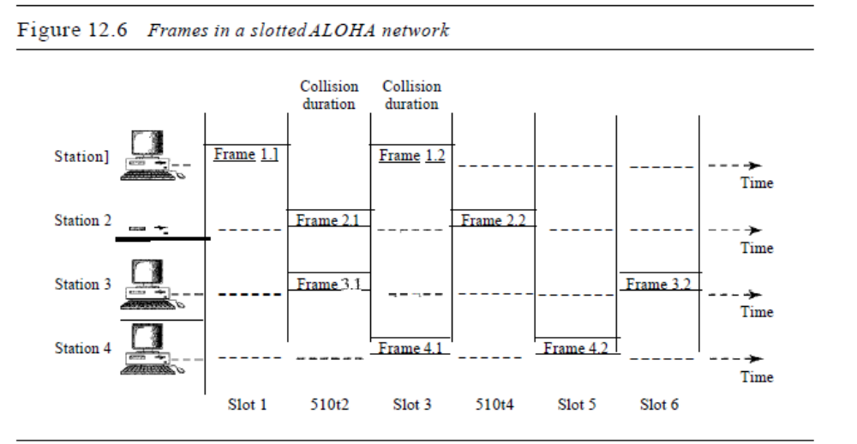

Because a station is allowed to send only at the beginning of the synchronized time
slot, if a station misses this moment, it must wait until the beginning of the next time
slot. This means that the station which started at the beginning of this slot has already
finished sending its frame. Of course, there is still the possibility of collision if two stations
try to send at the beginning of the same time slot. However, the vulnerable time is
now reduced to one-half, equal to Tfr Figure 12.7 shows the situation.
Figure 12.7 shows that the vulnerable time for slotted ALOHA is one-half that of
pure ALOHA
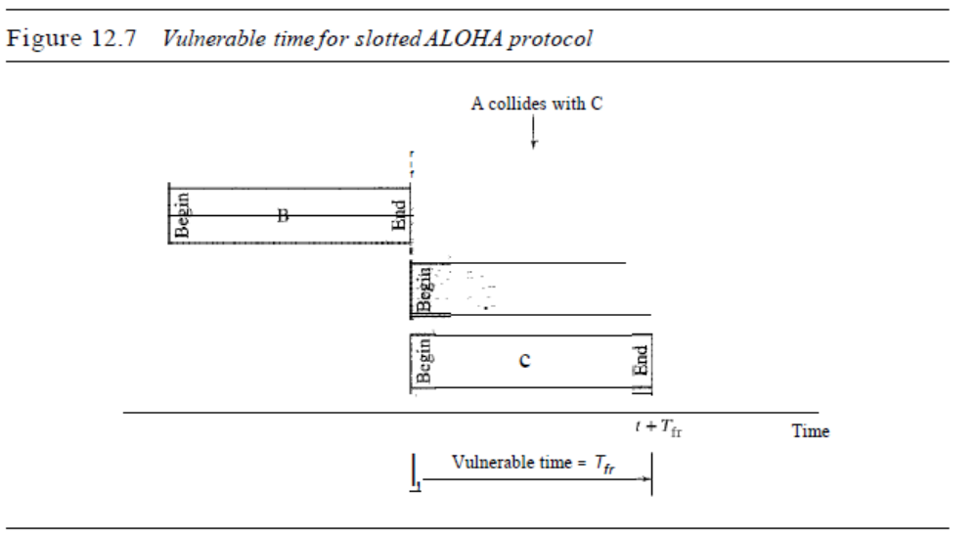.
Throughput It can be proved that the average number of successful transmissions for
slotted ALOHA is S = G x e-G. The maximum throughput Smax is 0.368, when G = 1.
In other words, if a frame is generated during one frame transmission time, then 36.8
percent of these frames reach their destination successfully. This result can be expected
because the vulnerable time is equal to the frame transmission time. Therefore, if a station
generates only one frame in this vulnerable time (and no other station generates a
frame during this time), the frame will reach its destination successfully.
The throughput for slottedALOHA is S =: G x e-G.
The maximum throughput Smax == 0.368 when G=1.
Example 12.4
A slotted ALOHA network transmits 200-bit frames using a shared channel with a 200-kbps
bandwidth. Find the throughput if the system (all stations together) produces
a. 1000 frames per second
b. 500 frames per second
c. 250 frames per second
Solution
This situation is similar to the previous exercise except that the network is using slotted ALOHA
instead of pure ALOHA. The frame transmission time is 200/200 kbps or 1 ms.
a. In this case G is 1. So S =G x e-G or S =0.368 (36.8 percent). This means that the
throughput is 1000 x 0.0368 =368 frames. Only 368 out of 1000 frames will probably
survive. Note that this is the maximum throughput case, percentagewise.
b. Here G is ~. In this case S =G x e-G or S =0.303 (30.3 percent). This means that the
throughput is 500 x 0.0303 =151. Only 151 frames out of 500 will probably survive.
c. Now Gis 1. In this case S =G x e-G or S =0.195 (19.5 percent). This means that the
throughput
4
is 250 x 0.195 = 49. Only 49 frames out of 250 will probably survive.
Carrier Sense Multiple Access (CSMA)
To minimize the chance of collision and, therefore, increase the performance, the CSMA
method was developed. The chance of collision can be reduced if a station senses the
medium before trying to use it. Carrier sense multiple access (CSMA) requires that each
station first listen to the medium (or check the state of the medium) before sending. In other
words, CSMA is based on the principle "sense before transmit" or "listen before talk."
CSMA can reduce the possibility of collision, but it cannot eliminate it. The reason
for this is shown in Figure 12.8, a space and time model of a CSMA network. Stations
are connected to a shared channel (usually a dedicated medium).
The possibility of collision still exists because of propagation delay; when a station
sends a frame, it still takes time (although very short) for the first bit to reach every station
Figure 12.8 Space/time model of the collision in CSMA
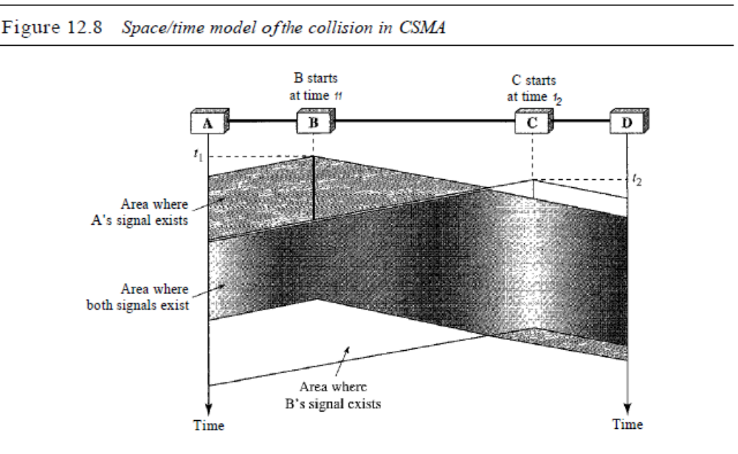

and for every station to sense it. In other words, a station may sense the medium and find
it idle, only because the first bit sent by another station has not yet been received.
At time tI' station B senses the medium and finds it idle, so it sends a frame. At time
t2 (t2> tI)' station C senses the medium and finds it idle because, at this time, the first
bits from station B have not reached station C. Station C also sends a frame. The two
signals collide and both frames are destroyed.
Vulnerable Time
The vulnerable time for CSMA is the propagation time Tp . This is the time needed for
a signal to propagate from one end of the medium to the other. When a station sends a
frame, and any other station tries to send a frame during this time, a collision will
result. But if the first bit of the frame reaches the end of the medium, every station will
already have heard the bit and will refrain from sending. Figure 12.9 shows the worst
Figure 12.9 Vulnerable time in CSMA
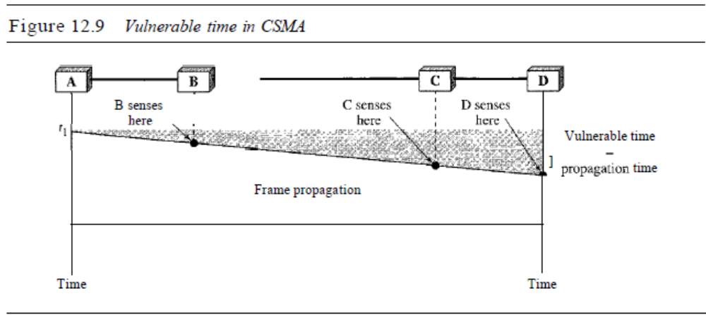MULTIPLE ACCESS
case. The leftmost station A sends a frame at time tl' which reaches the rightmost station
D at time tl + Tp . The gray area shows the vulnerable area in time and space.
Persistence Methods
What should a station do if the channel is busy? What should a station do if the channel
is idle? Three methods have been devised to answer these questions: the I-persistent
method, the nonpersistent method, and the p-persistent metod. Figure 12.10 shows the
behavior of three persistence methods when a station finds a channel busy.
Figure 12.10 Behavior of three persistence methods
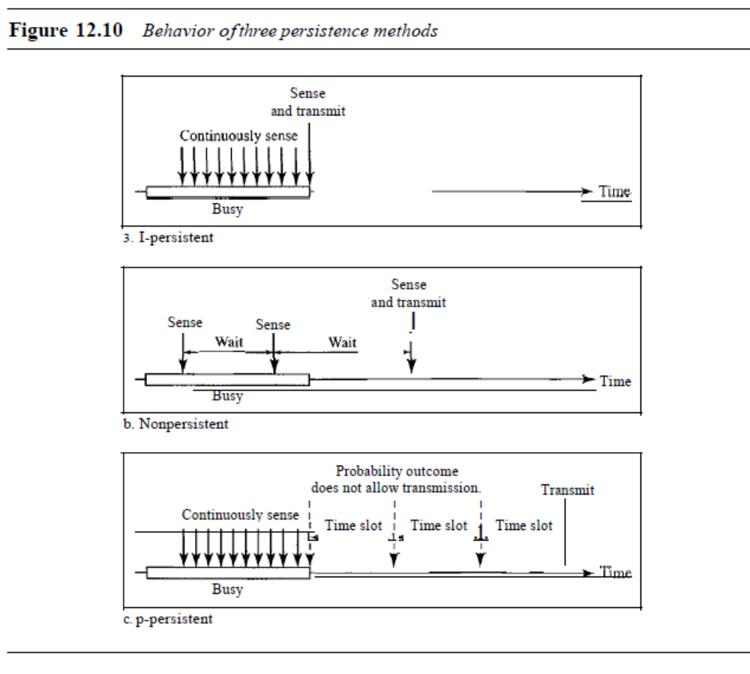Figure 12.11 shows the flow diagrams for these methods.
I-Persistent The I-persistent method is simple and straightforward. In this method,
after the station finds the line idle, it sends its frame immediately (with probability I).
This method has the highest chance of collision because two or more stations may find
the line idle and send their frames immediately. We will see in Chapter 13 that Ethernet
uses this method.
Nonpersistent In the nonpersistent method, a station that has a frame to send
senses the line. If the line is idle, it sends immediately. If the line is not idle, it waits a
SECTION 12.1 RANDOMACCESS 373
Figure 12.11 Flow diagram for three persistence methods
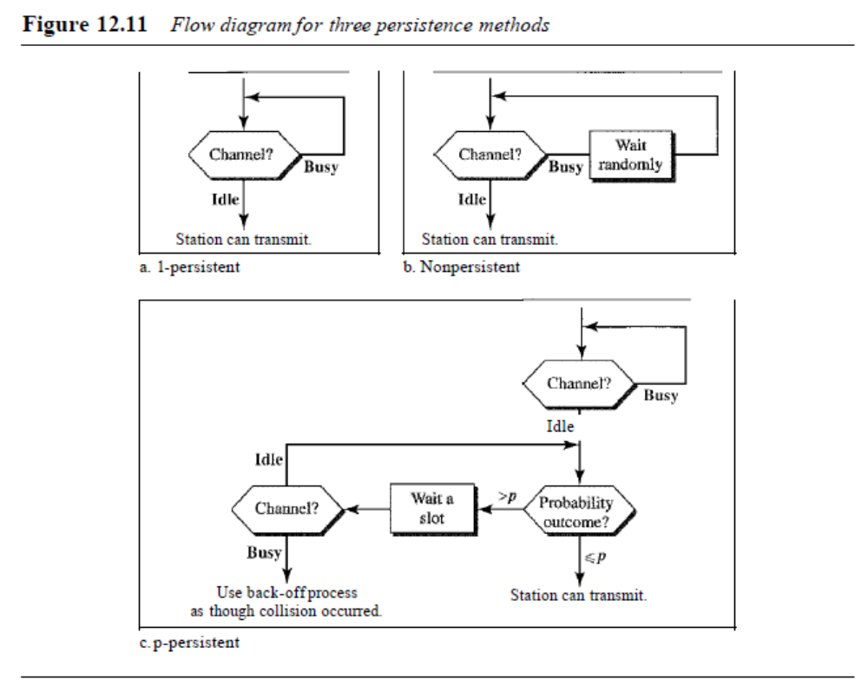
random amount of time and then senses the line again. The nonpersistent approach
reduces the chance of collision because it is unlikely that two or more stations will wait
the same amount of time and retry to send simultaneously. However, this method
reduces the efficiency of the network because the medium remains idle when there may
be stations with frames to send.
p-Persistent Thep-persistent method is used if the channel has time slots with a slot
duration equal to or greater than the maximum propagation time. The p-persistent approach
combines the advantages of the other two strategies. It reduces the chance of collision and
improves efficiency. In this method, after the station finds the line idle it follows these steps:
1. With probability p, the station sends its frame.
2. With probability q = 1 - p, the station waits for the beginning of the next time slot
and checks the line again.
a. If the line is idle, it goes to step 1.
b. If the line is busy, it acts as though a collision has occurred and uses the backoff
procedure.
Carrier Sense Multiple Access with Collision Detection (CSMA/CD)
The CSMA method does not specify the procedure following a collision. Carrier sense
multiple access with collision detection (CSMA/CD) augments the algorithm to handle
the collision.

In this method, a station monitors the medium after it sends a frame to see if the
transmission was successful. If so, the station is finished. If, however, there is a collision,
the frame is sent again.
To better understand CSMA/CD, let us look at the first bits transmitted by the two
stations involved in the collision. Although each station continues to send bits in the
frame until it detects the collision, we show what happens as the first bits collide. In
Figure 12.12, stations A and C are involved in the collision.
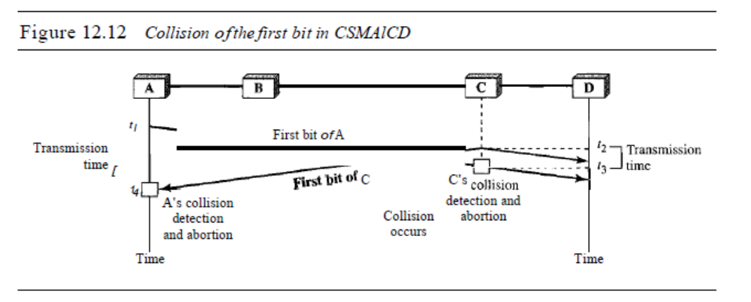
At time t 1, station A has executed its persistence procedure and starts sending the
bits of its frame. At time t2, station C has not yet sensed the first bit sent by A. Station C
executes its persistence procedure and starts sending the bits in its frame, which propagate
both to the left and to the right. The collision occurs sometime after time t2' Station C
detects a collision at time t3 when it receives the first bit of A's frame. Station C immediately
(or after a short time, but we assume immediately) aborts transmission. Station A
detects collision at time t4 when it receives the first bit of C's frame; it also immediately
aborts transmission. Looking at the figure, we see that A transmits for the duration t4 - tl;
C transmits for the duration t3 - t2' Later we show that, for the protocol to work, the
length of any frame divided by the bit rate in this protocol must be more than either of
these durations. At time t4, the transmission of A:s frame, though incomplete, is aborted;
at time t3, the transmission of B's frame, though incomplete, is aborted.
Now that we know the time durations for the two transmissions, we can show a
more complete graph in Figure 12.13.
Minimum Frame Size
For CSMAlCD to work, we need a restriction on the frame size. Before sending the last
bit of the frame, the sending station must detect a collision, if any, and abort the transmission.
This is so because the station, once the entire frame is sent, does not keep a copy of
the frame and does not monitor the line for collision detection. Therefore, the frame transmission
time Tfr must be at least two times the maximum propagation time Tp. To understand
the reason, let us think about the worst-case scenario. If the two stations involved in
a collision are the maximum distance apart, the signal from the first takes time Tp to reach
the second, and the effect of the collision takes another time Tp to reach the first. So the
requirement is that the first station must still be transmitting after 2Tp .
Figure 12.13 Collision and abortion in CSMAlCD
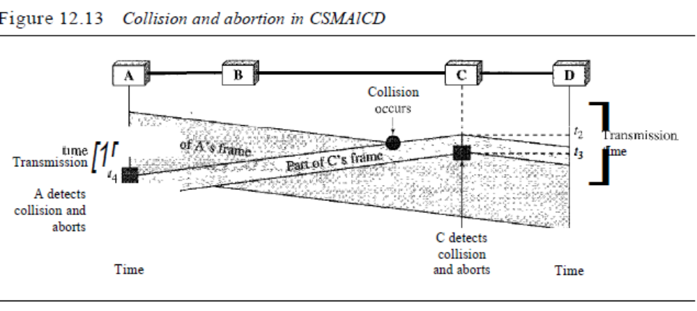
Example 12.5
A network using CSMA/CD has a bandwidth of 10 Mbps. If the maximum propagation time (including the delays in the devices and ignoring the time needed to send a jamming signal, as we see later) is 25.611S, what is the minimum size of the frame?
Solution
The frame transmission time is Tfr = 2 x Tp =51.2 ~s. This means, in the worst case, a station
needs to transmit for a period of 51.2 ~s to detect the collision. The minimum size of the frame
is 10 Mbps x 51.2 !-ls =512 bits or 64 bytes. This is actually the minimum size of the frame for
Standard Ethernet, as we will see in Chapter 13.
Procedure
Now let us look at the flow diagram for CSMAlCD in Figure 12.14. It is similar to the
one for the ALOHA protocol, but there are differences.
The first difference is the addition of the persistence process. We need to sense the
channel before we start sending the frame by using one of the persistence processes we
discussed previously (nonpersistent, I-persistent, or p-persistent). The corresponding
box can be replaced by one of the persistence processes shown in Figure 12.11.
The second difference is the frame transmission. In ALOHA, we first transmit the
entire frame and then wait for an acknowledgment. In CSMA/CD, transmission and
collision detection is a continuous process. We do not send the entire frame and then
look for a collision. The station transmits and receives continuously and simultaneously
(using two different ports). We use a loop to show that transmission is a continuous
process. We constantly monitor in order to detect one of two conditions: either transmission
is finished or a collision is detected. Either event stops transmission. When we
come out of the loop, if a collision has not been detected, it means that transmission is
complete; the entire frame is transmitted. Otherwise, a collision has occurred.
The third difference is the sending of a short jamming signal that enforces the collision
in case other stations have not yet sensed the collision.
Energy Level
We can say that the level of energy in a channel can have three values: zero, normal,
and abnormal. At the zero level, the channel is idle. At the normal level, a station has
Figure 12.14 Flow diagramfor the CSMAlCD
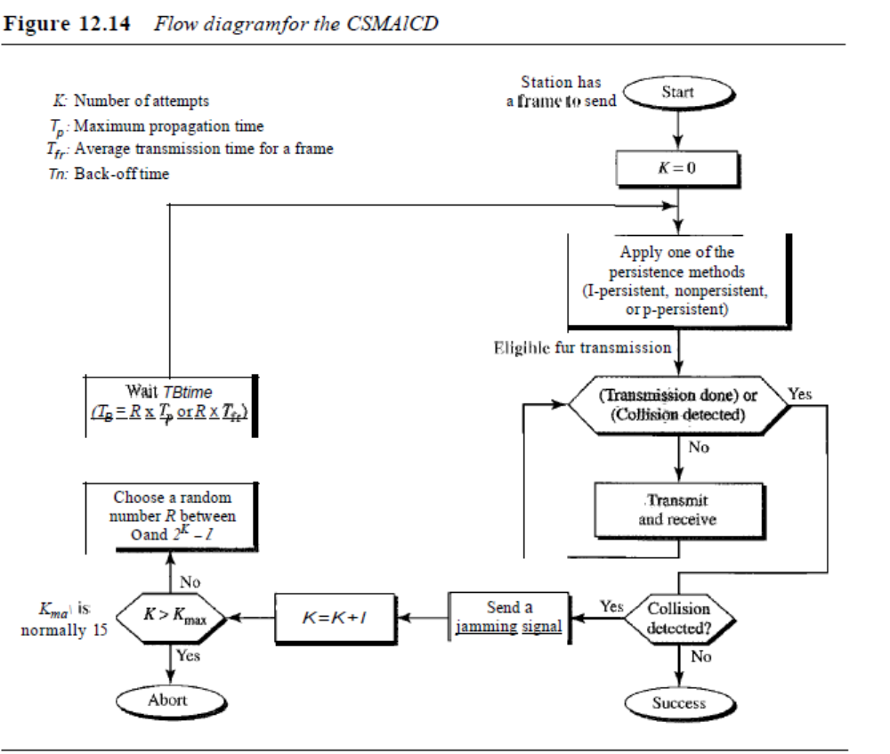Send a
jamming signal
successfully captured the channel and is sending its frame. At the abnormal level, there
is a collision and the level of the energy is twice the normal level. A station that has a
frame to send or is sending a frame needs to monitor the energy level to determine if
the channel is idle, busy, or in collision mode. Figure 12.15 shows the situation.
Figure 12.15 Energy level during transmission, idleness, or collision
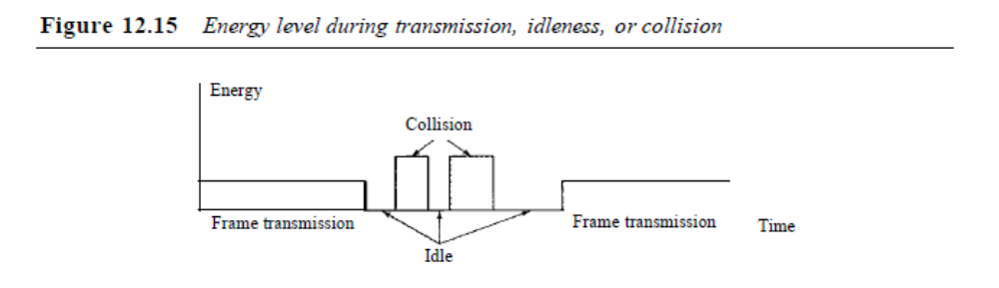
Throughput
The throughput of CSMAlCD is greater than that of pure or slotted ALOHA. The maximum
throughput occurs at a different value of G and is based on the persistence method
SECTION 12.1 RANDOMACCESS 377
and the value of p in the p-persistent approach. For I-persistent method the maximum
throughput is around 50 percent when G =1. For nonpersistent method, the maximum
throughput can go up to 90 percent when G is between 3 and 8.
Carrier Sense Multiple Access with
Collision Avoidance (CSMA/CA)
The basic idea behind CSMA/CD is that a station needs to be able to receive while
transmitting to detect a collision. When there is no collision, the station receives one
signal: its own signal. When there is a collision, the station receives two signals: its own
signal and the signal transmitted by a second station. To distinguish between these two
cases, the received signals in these two cases must be significantly different. In other
words, the signal from the second station needs to add a significant amount of energy to
the one created by the first station.
In a wired network, the received signal has almost the same energy as the sent signal
because either the length of the cable is short or there are repeaters that amplify the
energy between the sender and the receiver. This means that in a collision, the detected
energy almost doubles.
However, in a wireless network, much of the sent energy is lost in transmission. The
received signal has very little energy. Therefore, a collision may add only 5 to 10 percent
additional energy. This is not useful for effective collision detection.
We need to avoid collisions on wireless networks because they cannot be detected.
Carrier sense multiple access with collision avoidance (CSMAlCA) was invented for this
network. Collisions are avoided through the use of CSMAICA's three strategies: the interframe
space, the contention window, and acknowledgments, as shown in Figure 12.16.
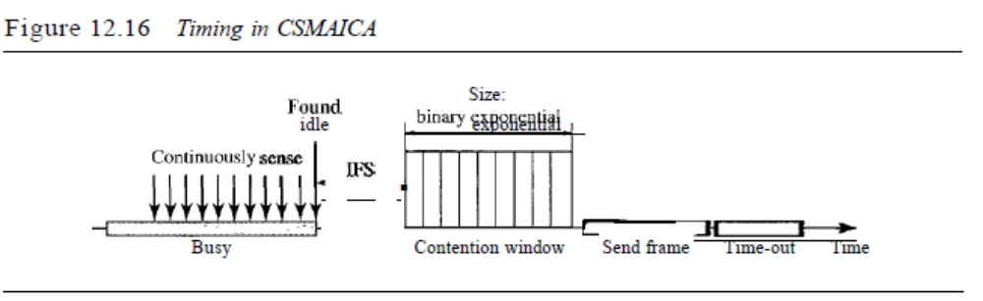Interframe Space (IFS)
First, collisions are avoided by deferring transmission even if the channel is found idle.
When an idle channel is found, the station does not send immediately. It waits for a
period of time called the interframe space or IFS. Even though the channel may
appear idle when it is sensed, a distant station may have already started transmitting.
The distant station's signal has not yet reached this station. The IFS time allows the
front of the transmitted signal by the distant station to reach this station. If after the IFS
time the channel is still idle, the station can send, but it still needs to wait a time equal
to the contention time (described next). The IFS variable can also be used to prioritize
378 CHAPTER 12 MULTIPLE ACCESS
stations or frame types. For example, a station that is assigned a shorter IFS has a
higher priority.
In CSMAlCA, the IFS can also be used to define
the priority of a station or a frame.
Contention Window
The contention window is an amount of time divided into slots. A station that is ready
to send chooses a random number of slots as its wait time. The number of slots in the
window changes according to the binary exponential back-off strategy. This means that
it is set to one slot the first time and then doubles each time the station cannot detect an
idle channel after the IFS time. This is very similar to the p-persistent method except
that a random outcome defines the number of slots taken by the waiting station. One
interesting point about the contention window is that the station needs to sense the
channel after each time slot. However, if the station finds the channel busy, it does not
restart the process; it just stops the timer and restarts it when the channel is sensed as
idle. This gives priority to the station with the longest waiting time.
In CSMAlCA, if the station finds the channel busy,
it does not restart the timer of the contention window;
it stops the timer and restarts it when the channel becomes idle.
Acknowledgment
With all these precautions, there still may be a collision resulting in destroyed data.
In addition, the data may be corrupted during the transmission. The positive acknowledgment
and the time-out timer can help guarantee that the receiver has received the
frame.
Procedure
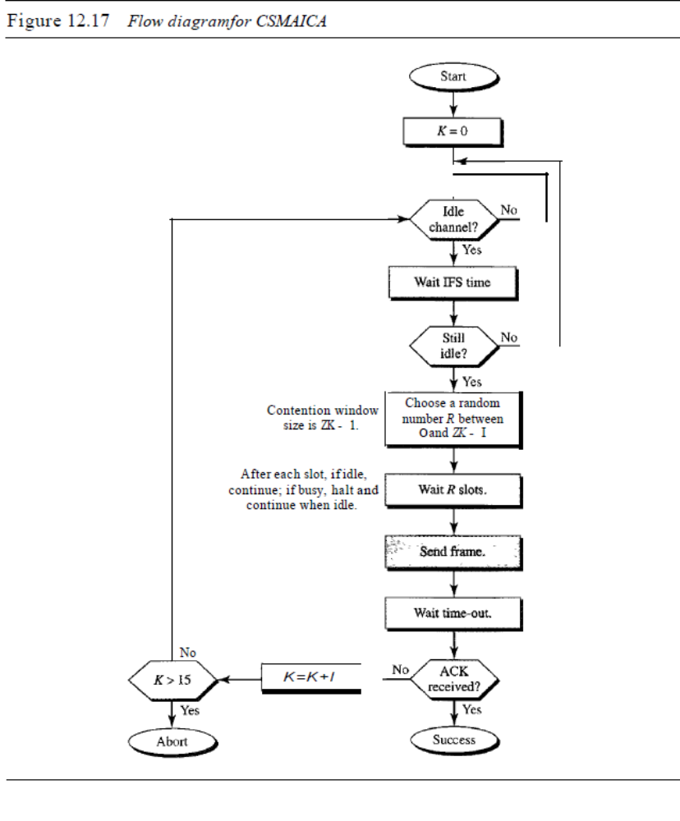
Figure 12.17 shows the procedure. Note that the channel needs to be sensed before and
after the IFS. The channel also needs to be sensed during the contention time. For each
time slot of the contention window, the channel is sensed. If it is found idle, the timer
continues; if the channel is found busy, the timer is stopped and continues after the
timer becomes idle again.
CSMAICA and Wireless Networks
CSMAICA was mostly intended for use in wireless networks. The procedure described
above, however, is not sophisticated enough to handle some particular issues related to
wireless networks, such as hidden terminals or exposed terminals. We will see how
these issues are solved by augmenting the above protocol with hand-shaking features.
The use ofCSMNCA in wireless networks will be discussed in Chapter 14.
SECTION 12.2 CONTROLLED ACCESS 379
Figure 12.17 Flow diagramfor CSMAICA
12.3 CHANNELIZATION
Channelization is a multiple-access method in which the available bandwidth of a link
is shared in time, frequency, or through code, between different stations. In this section,
we discuss three channelization protocols: FDMA, TDMA, and CDMA.
We see the application of all these methods in Chapter 16
when we discuss cellular phone systems.
Frequency-Division Multiple Access (FDMA)
In frequency-division multiple access (FDMA), the available bandwidth is divided
into frequency bands. Each station is allocated a band to send its data. In other words,
each band is reserved for a specific station, and it belongs to the station all the time.
Each station also uses a band pass filter to confine the transmitter frequencies. To prevent
station interferences, the allocated bands are separated from one another by small
guard bands. Figure 12.21 shows the idea of FDMA.
Figure 12.21 Frequency-division multiple access (FDMA)
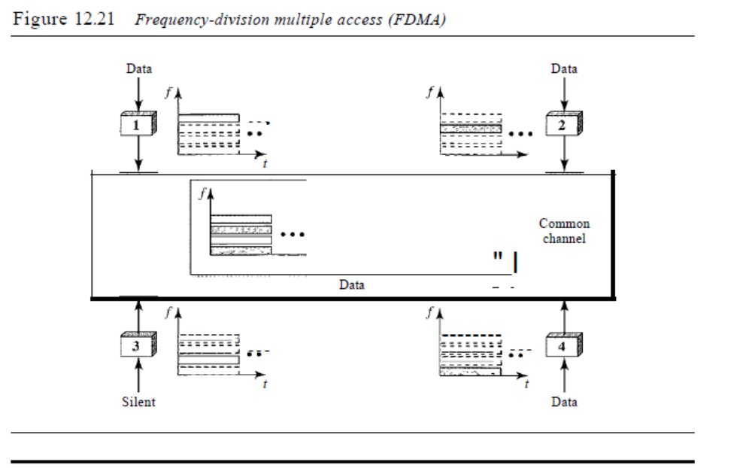In FDMA, the available bandwidth of the common channel
is divided into bands that are separated by guard bands.
384 CHAPTER 12 MULTIPLE ACCESS
FDMA specifies a predetermined frequency band for the entire period of communication.
This means that stream data (a continuous flow of data that may not be packetized)
can easily be used with FDMA. We will see in Chapter 16 how this feature can
be used in cellular telephone systems.
We need to emphasize that although FDMA and FDM conceptually seem similar,
there are differences between them. FDM, as we saw in Chapter 6, is a physical layer
technique that combines the loads from low-bandwidth channels and transmits them by
using a high-bandwidth channel. The channels that are combined are low-pass. The
multiplexer modulates the signals, combines them, and creates a bandpass signal. The
bandwidth of each channel is shifted by the multiplexer.
FDMA, on the other hand, is an access method in the data link layer. The data link
layer in each station tells its physical layer to make a bandpass signal from the data
passed to it. The signal must be created in the allocated band. There is no physical multiplexer
at the physical layer. The signals created at each station are automatically
bandpass-filtered. They are mixed when they are sent to the common channel.
Time-Division Multiple Access (TDMA)
In time-division multiple access (TDMA), the stations share the bandwidth of the
channel in time. Each station is allocated a time slot during which it can send data.
Each station transmits its data in is assigned time slot. Figure 12.22 shows the idea
behind TDMA.
Figure 12.22 Time-division multiple access (TDMA)
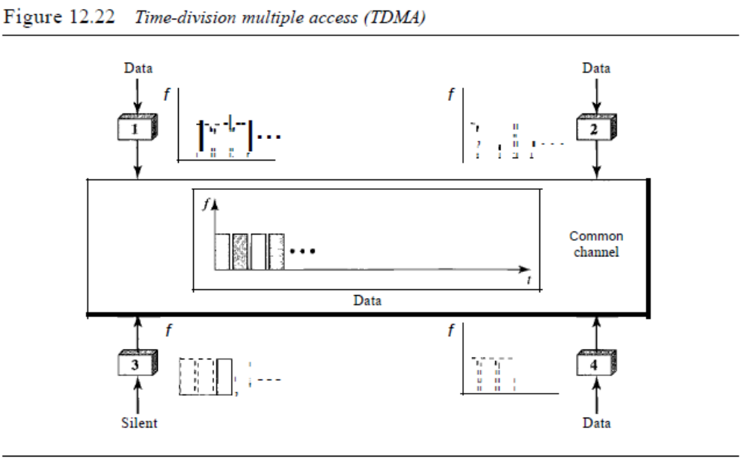The main problem with TDMA lies in achieving synchronization between the different
stations. Each station needs to know the beginning of its slot and the location of its slot.
This may be difficult because of propagation delays introduced in the system if the stations
are spread over a large area. To compensate for the delays, we can insert guard
SECTION 12.3 CHANNELIZATION 385
times. Synchronization is normally accomplished by having some synchronization bits
(normally refened to as preamble bits) at the beginning of each slot.
In TDMA, the bandwidth is just one channel that is
timeshared between different stations.
We also need to emphasize that although TDMA and TDM conceptually seem the
same, there are differences between them. TDM, as we saw in Chapter 6, is a physical
layer technique that combines the data from slower channels and transmits them by
using a faster channel. The process uses a physical multiplexer that interleaves data
units from each channel.
TDMA, on the other hand, is an access method in the data link layer. The data link
layer in each station tells its physical layer to use the allocated time slot. There is no
physical multiplexer at the physical layer.
Code-Division Multiple Access (CDMA)
Code-division multiple access (CDMA) was conceived several decades ago. Recent
advances in electronic technology have finally made its implementation possible.
CDMA differs from FDMA because only one channel occupies the entire bandwidth of
the link. It differs from TDMA because all stations can send data simultaneously; there
is no timesharing.
In CDMA, one channel carries all transmissions simultaneously.
Analogy
Let us first give an analogy. CDMA simply means communication with different codes.
For example, in a large room with many people, two people can talk in English if
nobody else understands English. Another two people can talk in Chinese if they are
the only ones who understand Chinese, and so on. In other words, the common channel,
the space of the room in this case, can easily allow communication between several
couples, but in different languages (codes).
Idea
Let us assume we have four stations 1, 2, 3, and 4 connected to the same channel. The
data from station 1 are d l , from station 2 are d2, and so on. The code assigned to the
first station is cI, to the second is c2, and so on. We assume that the assigned codes have
two properties.
1. If we multiply each code by another, we get O.
2. If we multiply each code by itself, we get 4 (the number of stations).
With these two properties in mind, let us see how the above four stations can send data
using the same common channel, as shown in Figure 12.23.
Station 1 mUltiplies (a special kind of multiplication, as we will see) its data by its
code to get d l . Cl' Station 2 multiplies its data by its code to get d2 . c2' And so on. The

Figure 12.23 Simple idea ofcommunication with code
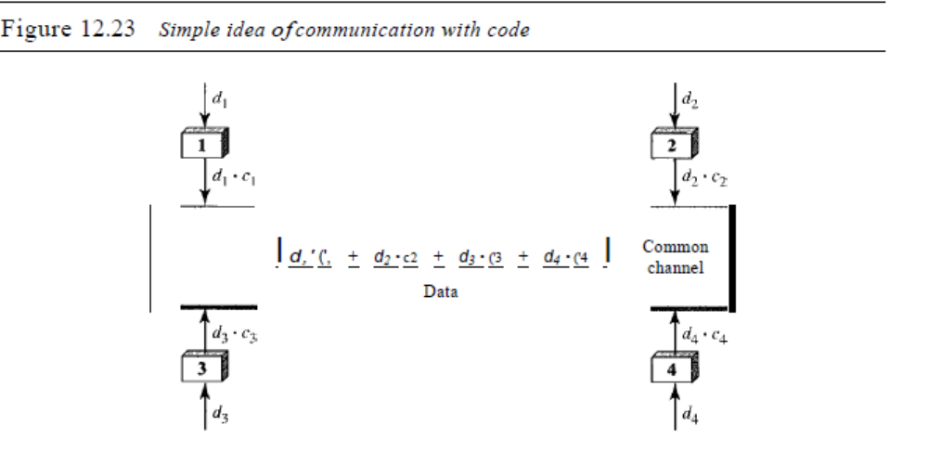data that go on the channel are the sum of all these terms, as shown in the box. Any
station that wants to receive data from one of the other three multiplies the data on the
channel by the code of the sender. For example, suppose stations 1 and 2 are talking to
each other. Station 2 wants to hear what station I is saying. It multiplies the data on the
channel by cl' the code of station 1.
Because (cl . cl) is 4, but (c2 . cI), (c3 . cI), and (c4 . cl) are all Os, station 2 divides
the result by 4 to get the data from station 1.
data =(d} . Cj + dz . Cz +d3 . C3 + d4 . c4) . Cl
=d j • Cl . Cj + dz. Cz . Cl + d3 . C3 . Cl + d4 . C4' CI =4 X d1
Chips
CDMA is based on coding theory. Each station is assigned a code, which is a sequence
of numbers called chips, as shown in Figure 12.24. The codes are for the previous
example.
Figure 12.24 Chip sequences
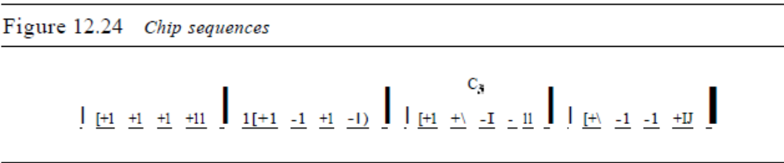Later in this chapter we show how we chose these sequences. For now, we need to
know that we did not choose the sequences randomly; they were carefully selected.
They are called orthogonal sequences and have the following properties:
1. Each sequence is made of N elements, where N is the number of stations.
SECTION 12.3 CHANNELIZATION 387
2. If we multiply a sequence by a number, every element in the sequence is multiplied
by that element. This is called multiplication of a sequence by a scalar. For example,
2. [+1 +1-1-1]=[+2+2-2-2]
3. If we multiply two equal sequences, element by element, and add the results, we
get N, where N is the number of elements in the each sequence. This is called the
inner product of two equal sequences. For example,
[+1 +1-1 -n· [+1 +1 -1 -1] = 1 + 1 + 1 + 1 = 4
4. If we multiply two different sequences, element by element, and add the results,
we get O. This is called inner product of two different sequences. For example,
[+1 +1 -1 -1] • [+1 +1 +1 +1] = 1 + 1 - 1 - 1 = 0
5. Adding two sequences means adding the corresponding elements. The result is
another sequence. For example,
[+1+1-1-1]+[+1+1+1+1]=[+2+2 00]
Data Representation
We follow these rules for encoding: If a station needs to send a 0 bit, it encodes it as -1;
if it needs to send a 1 bit, it encodes it as +1. When a station is idle, it sends no signal,
which is interpreted as a O. These are shown in Figure 12.25.
Figure 12.25 Data representation in CDMA
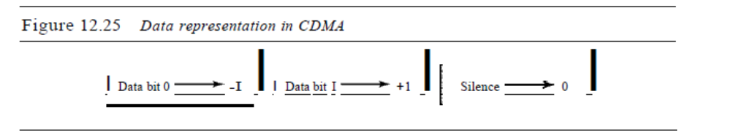
Encoding and Decoding
As a simple example, we show how four stations share the link during a I-bit interval.
The procedure can easily be repeated for additional intervals. We assume that stations 1
and 2 are sending a 0 bit and channel 4 is sending a 1 bit. Station 3 is silent. The data at
the sender site are translated to -1, -1, 0, and +1. Each station multiplies the corresponding
number by its chip (its orthogonal sequence), which is unique for each station. The
result is a new sequence which is sent to the channel. For simplicity, we assume that all
stations send the resulting sequences at the same time. The sequence on the channel is
the sum of all four sequences as defined before. Figure 12.26 shows the situation.
Now imagine station 3, which we said is silent, is listening to station 2. Station 3 multiplies
the total data on the channel by the code for station 2, which is [+1 -1 +1-1], to get
[-1-1-3 +1]· [+1-1 +1-1] =-4/4 =-1 ...... bit 1
388 CHAPTER 12 MULTIPLE ACCESS
Figure 12.26 Sharing channel in CDMA
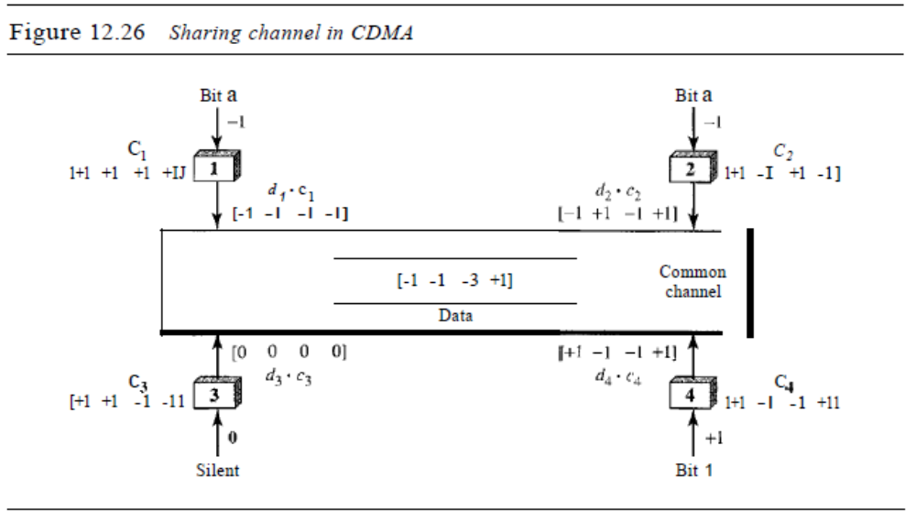
Signal Level
The process can be better understood if we show the digital signal produced by each
station and the data recovered at the destination (see Figure 12.27). The figure shows the
corresponding signals for each station (using NRZ-L for simplicity) and the signal that
is on the common channel.
Figure 12.27 Digital signal created by four stations in CDMA
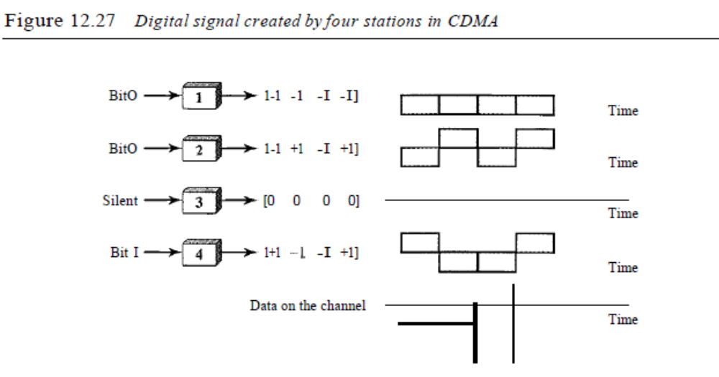Figure 12.28 shows how station 3 can detect the data sent by station 2 by using the
code for station 2. The total data on the channel are multiplied (inner product operation)
by the signal representing station 2 chip code to get a new signal. The station then
integrates and adds the area under the signal, to get the value -4, which is divided by 4
and interpreted as bit O.
SECTION 12.3 CHANNELIZATION 389
Figure 12.28 Decoding ofthe composite signal for one in CDMA
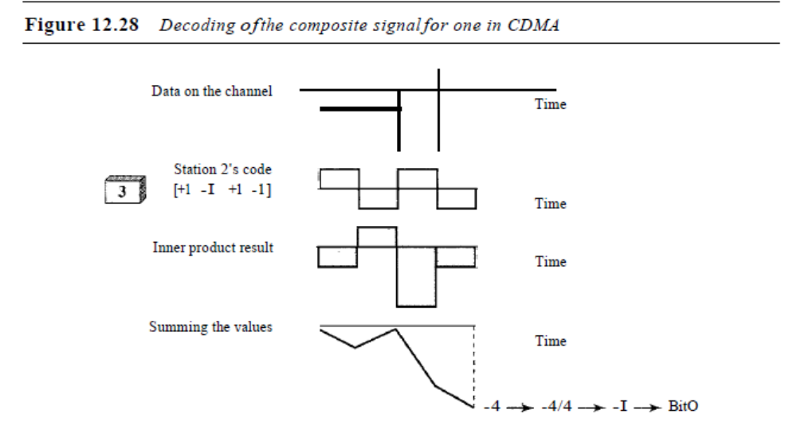Sequence Generation
To generate chip sequences, we use a Walsh table, which is a two-dimensional table with
an equal number of rows and columns, as shown in Figure 12.29.
Figure 12.29 General rule and examples of creating Walsh tables
a. Two basic rules
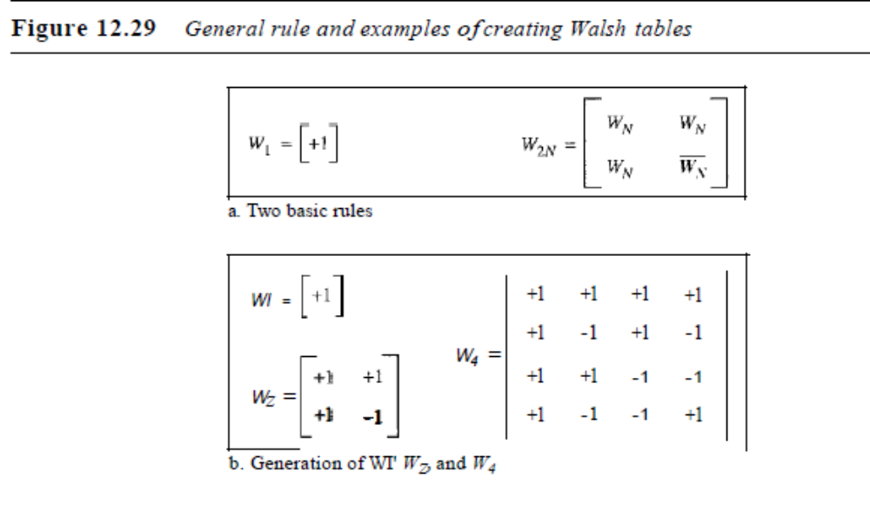b. Generation of WI' Wz, and W4
In the Walsh table, each row is a sequence of chips. WI for a one-chip sequence has
one row and one column. We can choose -lor +1 for the chip for this trivial table (we
chose +1). According to Walsh, if we know the table for N sequences WN' we can create
the table for 2N sequences W2N, as shown in Figure 12.29. The WN with the overbar WN
stands for the complement of WN' where each +1 is changed to -1 and vice versa.
Figure 12.29 also shows how we can create W2 and W4 from WI' After we select WI, W2
390 CHAPTER 12 MULTIPLE ACCESS
can be made from four Wj 's, with the last one the complement of Wl' After W2 is generated,
W4 can be made of four W2's, with the last one the complement of W2. Of course,
Ws is composed of four W4's, and so on. Note that after WN is made, each station is
assigned a chip corresponding to a row.
Something we need to emphasize is that the number of sequences N needs to be a
power of 2. In other words, we need to have N = 2m.
The number of sequences in a Walsh table needs to beN = 2m.
Example 12.6
Find the chips for a network with
a. Two stations
b. Four stations
Solution
We can use the rows of W2 and W4 in Figure 12.29:
a. For a two-station network, we have [+1 +1] and [+1 -1].
b. For a four-station network we have [+1 +1 +1 +1], [+1 -1 +1 -1], [+1 +1 -1 -1], and
[+1-1-1 +1].
Example 12.7
What is the number of sequences if we have 90 stations in our network?
Solution
The number of sequences needs to be 2m. We need to choose m = 7 and N = 27 or 128. We can
then use 90 of the sequences as the chips.
Example 12.8
Prove that a receiving station can get the data sent by a specific sender if it multiplies the entire
data on the channel by the sender's chip code and then divides it by the number of stations.
Solution
Let us prove this for the first station, using our previous four-station example. We can say that the
data on the channel D =Cdl . ("1 + d2 . ("2 + d3 . ("3 + d4 . ("4)' The receiver which wants to get the
data sent by station I multiplies these data by ("I'
D . ("1 =(d1 • ("1 + d2 . ("2 + d3 . ("3 + d4 . ("4) . ("1
= d1 . ("1 . ("1 + d2 . ("2 . ("1 + d3 . ("3 . ("1 + d4 . ("4 . ("1
=d I X N + d2 X 0 + d3 X 0 + d4 X 0
=dl xN
When we divide the result by N, we get dI'

